Voltage, Current and Temperature Measurement Units:

Getting Started & Full Design

Written for: Product Health

www.producthealth.org

By: Renewable Energy Innovation

Written by: Matthew Little

[matt@re-innovation.co.uk](mailto:matt@re-innovation.co.uk)

www.re-innovation.co.uk

Date: 6th May 2014

Version: 0.0



**e:** [**info@re-innovation.co.uk**](mailto:info@re-innovation.co.uk)

**w:** [**www.re-innovation.co.uk**](http://www.re-innovation.co.uk)

**Hopkinson Gallery**

**21 Station Street**

**Nottingham**

**NG2 3AJ**

Contents

[Design overview 2](#_Toc388280968)

[License 4](#_Toc388280969)

[More information 4](#_Toc388280970)

[Specifications 4](#_Toc388280971)

[Getting started guide 5](#_Toc388280972)

[Parts required: 5](#_Toc388280973)

[Wiring 6](#_Toc388280974)

[SD card image 8](#_Toc388280975)

[Raspberry Pi start up 8](#_Toc388280976)

[Checking data 10](#_Toc388280977)

[Change the configuration file 11](#_Toc388280978)

[Changing a post processing function 13](#_Toc388280979)

[Change Thermistor post processing 13](#_Toc388280980)

[Change Voltage post processing 14](#_Toc388280981)

[Change current post processing 14](#_Toc388280982)

[Slave unit - Hardware 15](#_Toc388280983)

[Slave hardware overview 15](#_Toc388280984)

[Microcontroller 16](#_Toc388280985)

[Sensors 17](#_Toc388280986)

[Current Sensor 18](#_Toc388280987)

[Voltage Sensor 18](#_Toc388280988)

[Temperature Sensor 19](#_Toc388280989)

[Operation Amplifier 20](#_Toc388280990)

[Analogue to Digital Converter (ADC) 20](#_Toc388280991)

[ADC for 1 Channel unit: 20](#_Toc388280992)

[ADC for 4 Channel unit 21](#_Toc388280993)

[Power Supplies 21](#_Toc388280994)

[5V regulator 21](#_Toc388280995)

[+/-15V regulator 21](#_Toc388280996)

[Reference Voltage 22](#_Toc388280997)

[Data output 22](#_Toc388280998)

[Serial 22](#_Toc388280999)

[XRF 23](#_Toc388281000)

[RS485 output 23](#_Toc388281001)

[ID switch 24](#_Toc388281002)

[EEPROM 24](#_Toc388281003)

[Test Switch 25](#_Toc388281004)

[Output LEDs 25](#_Toc388281005)

[Upload Arduino code to slave unit 26](#_Toc388281006)

[Test Mode for slave unit 28](#_Toc388281007)

[Slave unit 1 Channel circuit diagram 29](#_Toc388281008)

[PCB for the 1 Channel Slave Unit 36](#_Toc388281009)

[Parts List for 1 Channel Slave Unit 37](#_Toc388281010)

[Schematic diagram for 4 Channel Slave Unit 38](#_Toc388281011)

[PCB layout for 4 Channel Slave Unit 48](#_Toc388281012)

[Parts List for 4 Channel Slave Unit 50](#_Toc388281013)

[Slave unit - Software 51](#_Toc388281014)

[Software flow diagram 52](#_Toc388281015)

[Communications Protocol 53](#_Toc388281016)

[MODBUS specifications 54](#_Toc388281017)

[ADC readings 55](#_Toc388281018)

[1 Channel Unit 55](#_Toc388281019)

[4 Channel Unit 55](#_Toc388281020)

[Thermistor conversion 56](#_Toc388281021)

[Current conversion 56](#_Toc388281022)

[Voltage conversion 57](#_Toc388281023)

[Master unit - Hardware 59](#_Toc388281024)

[Raspberry Pi 59](#_Toc388281025)

[USB-RS485 converter 59](#_Toc388281026)

[Master Unit – Software 60](#_Toc388281027)

[How to prepare your OS 60](#_Toc388281028)

[How to download using git and build the installer 60](#_Toc388281029)

[How to: make installer tarball from github repo 60](#_Toc388281030)

[How to: use an installer tarball 61](#_Toc388281031)

[How to: check if FML is running 61](#_Toc388281032)

[How to: start & stop FML service 61](#_Toc388281033)

[How to: edit the configuration file 61](#_Toc388281034)

[Change serial port settings 61](#_Toc388281035)

[Change how frequently FML polls slave devices 61](#_Toc388281036)

[Add a new modbus slave 61](#_Toc388281037)

[Adding a new post-processing function 62](#_Toc388281038)

[Adding a register with a post-processing function 62](#_Toc388281039)

[How to: run in a terminal and see data coming through fml 63](#_Toc388281040)

[How to: add a graph to the web server 63](#_Toc388281041)

[Appendices 64](#_Toc388281042)

[Arduino code 64](#_Toc388281043)

[Typical application diagram 79](#_Toc388281044)

# Design overview

This document covers the full design and operation of a modular battery monitor.

It is also the ‘getting started’ guide for implementing a battery monitor system.

Batteries of all types are used for energy storage within renewable energy systems. They are a critical component within stand-alone (off-grid) power supply systems based upon renewable energy. Collecting data from the batteries within these systems helps with fault finding and preventative measures.

Useful battery parameters to measure are: Voltage, Current (in/out) and temperature.

This design is for a modular battery monitor unit which sends data back to a master unit, to be processed and stored.

This has been designed to be:

* Accurate
* Low cost
* Open-source
* Modular

There are two units within a basic system the master unit (which asks for data and stores/processed the data) and slave units (which measure the voltage, current and temperature data from the battery). Multiple slaves can be used within a system.

The Master unit is based upon the Raspberry Pi ([www.raspberrypi.org](http://www.raspberrypi.org)) .

The Slave units are based upon the Arduino ([www.arduino.cc](http://www.arduino.cc)).

The prototype was designed for Product Health ([www.producthealth.org](http://www.producthealth.org)) by Renewable Energy Innovation ([www.re-innovation.co.uk](http://www.re-innovation.co.uk)).

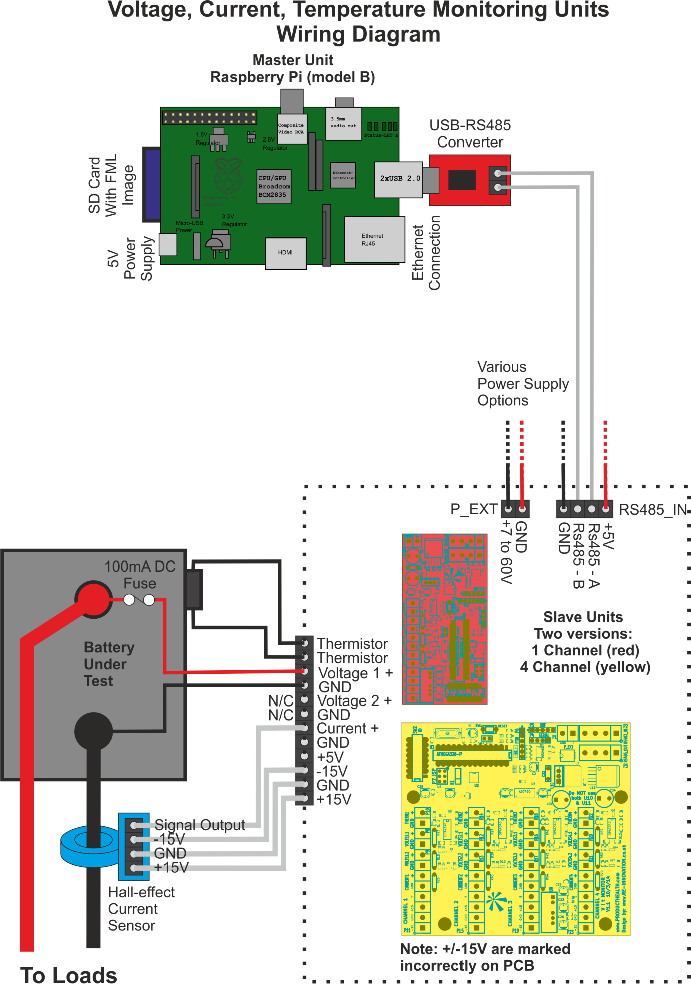

Wiring diagram

# License

This work is released under a Creative Commons By-Attribution Share-Alike 4.0 (CC BY-SA 4.0) license.

<http://creativecommons.org/licenses/by-sa/4.0/>



Please send any feedback to [info@re-innovation.co.uk](mailto:info@re-innovation.co.uk).

Please note: no responsibility is accepted for the accuracy of the information within this document. Use at your own risk.

# More information

Please contact [info@re-innovation.co.uk](mailto:info@re-innovation.co.uk) for more information on this project.

# Specifications

* Voltage levels: 0-60V DC (up to 48V battery banks)
* Current levels: up to +/-50A maximum (with different ranges)
* Temperature: -10 to 100C.
* Resolution: >10 bit accuracy
* Sample rate: >20Hz for each sensor

# Getting started guide

Basic information to get you going. Full design details are given later. Reading the whole of this document is recommended.

Note: Electrical knowledge is assumed here – if in doubt consult a qualified engineer.

Note: Batteries and high voltages are dangerous – Stay Safe.

## Parts required:

* Master Unit – Raspberry Pi
* USB-RS485 converter
* Slave Units – 1 channel or 4 channel
* Cable
* 5V power supply

## Equipment_Photo.jpg

You will also need the sensors to monitor your system including:

* Thermistors
* Hall-effect current sensors
* Cable/fuses for monitoring voltages

## Wiring

Depending upon the batteries to be measured, the following wiring diagram gives standard wiring for one battery.

It is recommended that the voltage measurements are fused with a 100mA in-line fuse.

Multiple slave units can be wired to the RS485 bus. Ensure each unit has a different device ID by adjusting the ID switches.

Power supply to the Slave units can either be a regulated 5V supply (ensure at least 200mA per a 1 channel slave unit or 750mA per 4 channel slave unit).

An external power supply can also be used (depending upon the power regulator chosen). This can range from 7VDC to 60V DC. It could also be powered from the battery under test, as long as this is not too high current draw for the system.

When powered, the ‘Heartbeat’ LED on the slave unit should flash approximately once per second.

The slave units can be tested by applying a jumper to the test pins. This will cause the device to stream data output. This can be viewed on the Raspberry Pi, or with a USB-Serial interface on a local computer.



## SD card image

Download the most recent SD card image and place in the Raspberry Pi slot. At least 4GB SD card is required.

## Raspberry Pi start up

You will need to know:

* The IP address of the Raspberry Pi (use an IPscanner if required)
* The user name and password for the Raspberry Pi (Default for a Raspberry Pi is: ‘pi’ and ‘raspberry’).

Firstly, wire up the board RS485 A to A and B to B, power connections.

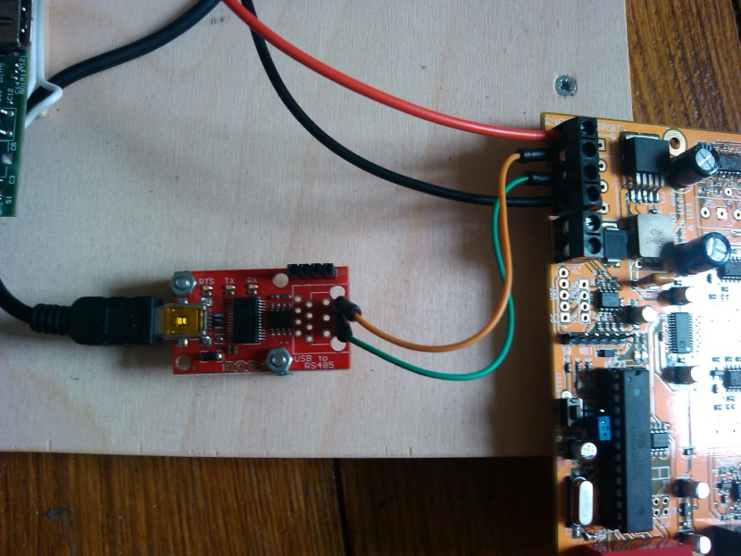

Set the Slave ID to 100. This is the default ID, but it can be changed as shown later.

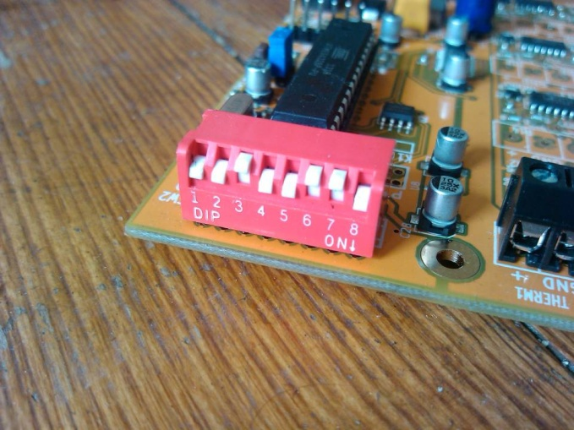

Connect Raspberry Pi to router with Ethernet cable.

Power up both Master and Slave units (any order).

Start an SSH client (I use PuTTy: <http://www.chiark.greenend.org.uk/~sgtatham/putty/>)

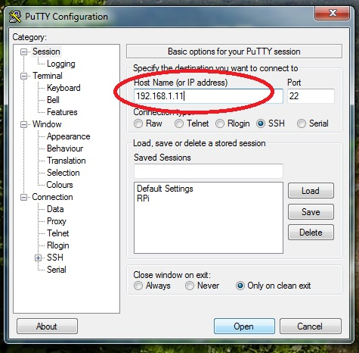

Connect to the RPi using its IP address.

Use the username and password (RPi default is “pi” and “raspberry”). You will see this start screen, which has information about useful files.

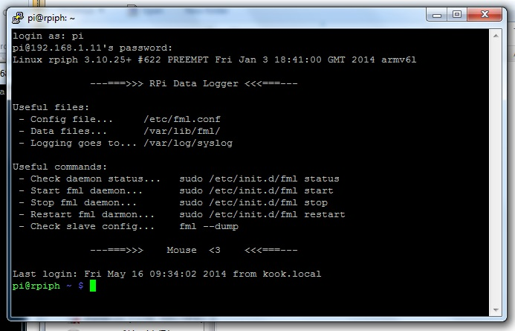

The FML daemon will run automatically.

## Checking data

We need to check that the data is being received by the master unit from the slave correctly.

To do this, we need to stop the FML daemon and run in a terminal.

To run in the terminal, stop the daemon mode instance of fml, and run the fml program directly:

$ sudo /etc/init.d/fml stop

$ sudo fml

You will then see the data arriving:

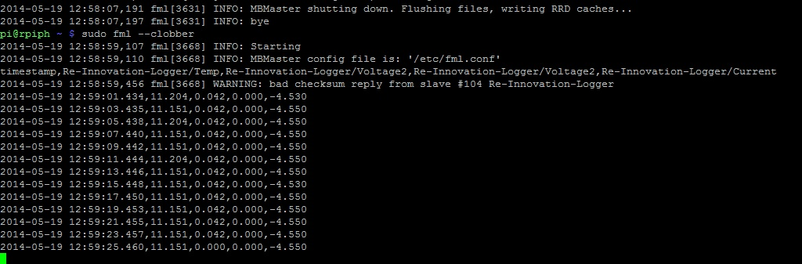You can check that the data looks OK here. This can be used each time the configuration (“/etc/fml.conf”) is changed.

To stop the terminal mode execution, press control-C. If desired, re-start the daemon mode:

$ sudo /etc/init.d/fml start

## Change the configuration file

The configuration file can be edited by opening it in an editor program. The Raspberry Pi is installed with nano, so lets use that:

$ sudo nano /etc/fml.conf

This will open the configuration file:

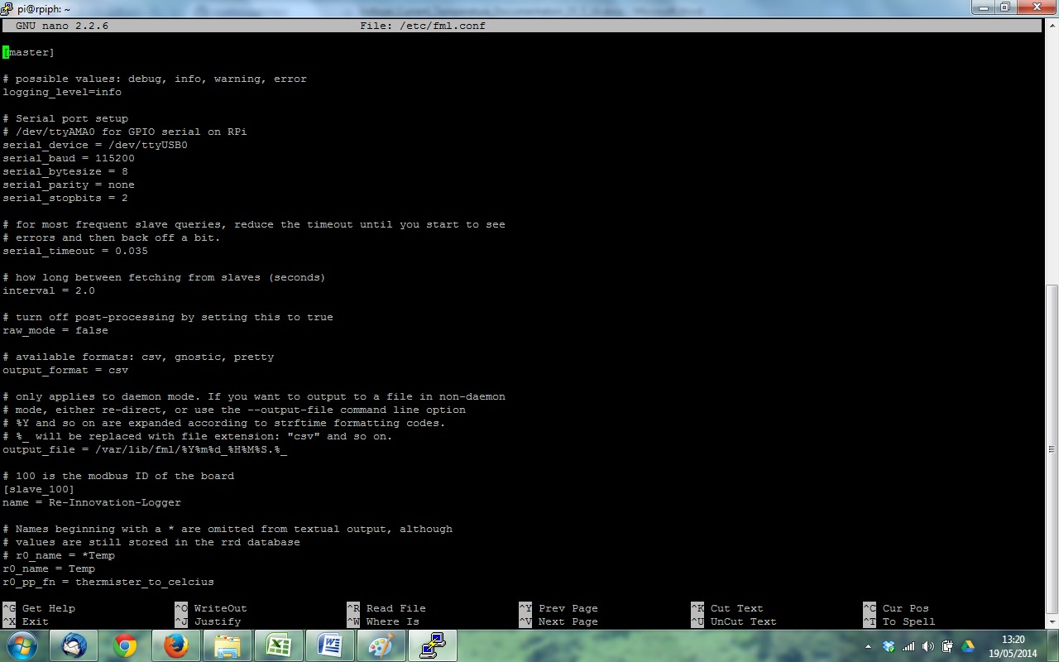

The .conf configuration file can be used to change the serial port settings, the slave ID(s), adding more slave units, change the temperature, voltage and current conversion parameters:

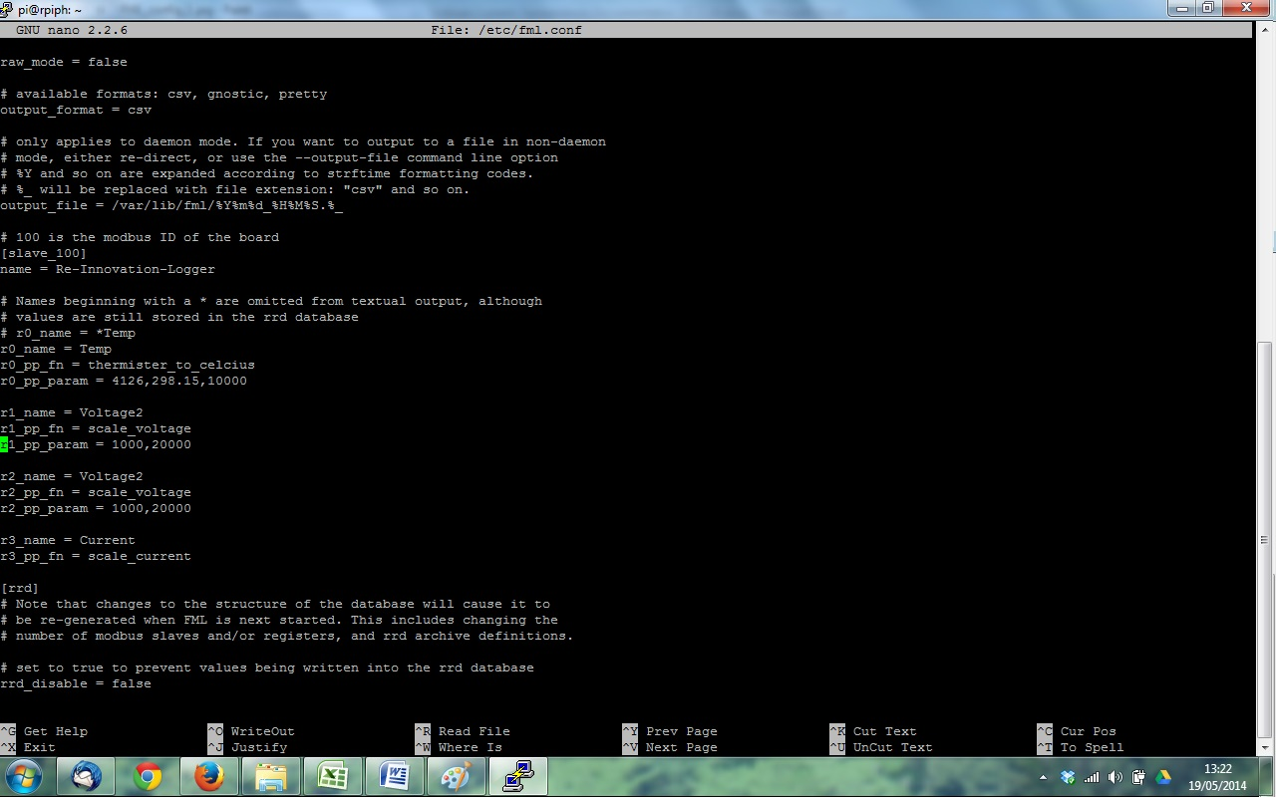

For example here we change the slave ID to 104:

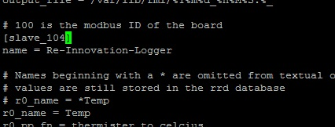

And here we change the thermistor nominal value to 47000 ohms:

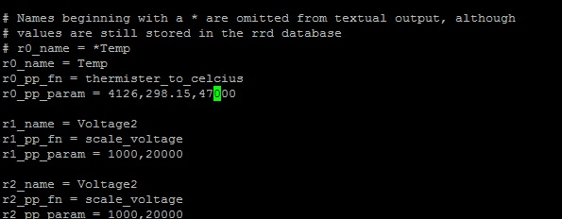

After changing the slave ID the round robin database will not function correctly, hence you will need to stop that database and re-start. This is done using the “ –clobber” command to create a new database.

Each time we change the configuration file we must restart the Daemon, using:

sudo /etc/init.d/fml stop

sudo /etc/init.d/fml start

## Changing a post processing function

The post processing functions convert the raw 12 bit value into the real-world value, such as temperature, current and voltage. You can write as many of these functions as you like, we have implemented thermistor to temperature, reading to current and reading to voltage.

To change the functions, we need to open the post-processing python script:

sudo nano /usr/local/lib/python2.7/dist-packages/pp\_functions.py

This will open the post processing functions python script:

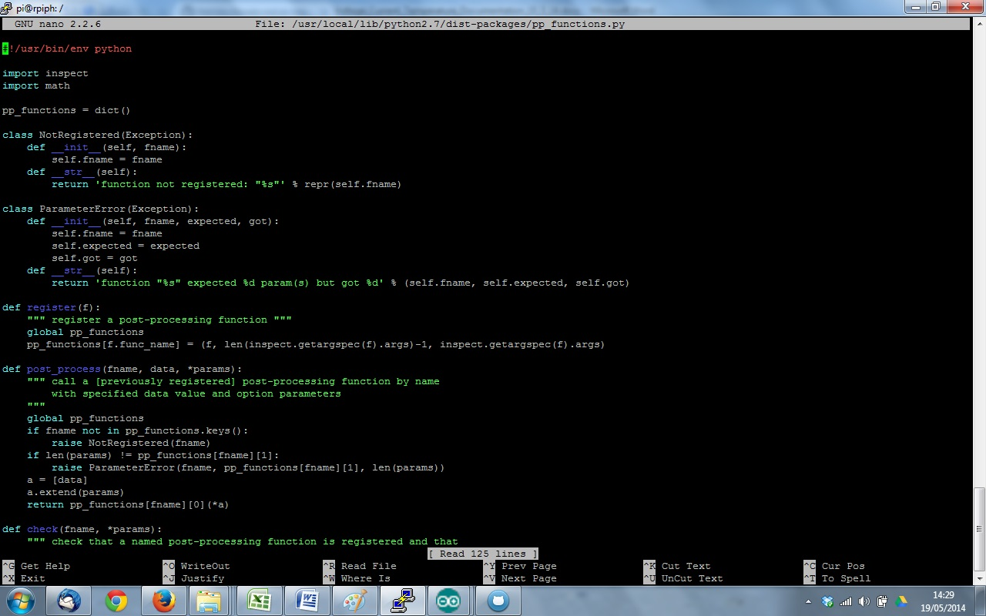

## Change Thermistor post processing

Thermistor values are converted using a standard conversion function:

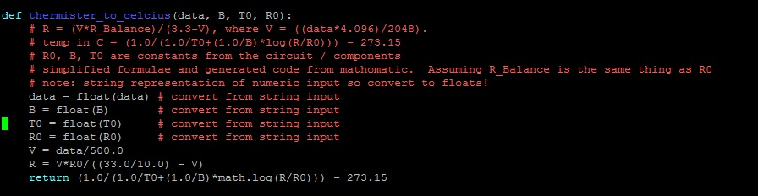

## Change Voltage post processing

Voltage processing depends upon the potential divider used. The function is give here, but may be different for your application:

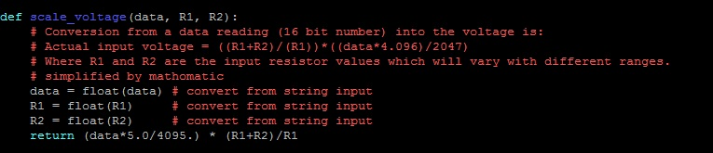

## Change current post processing

The current processing depends upon the hall-effect current sensor used. The function is given here, but may be different for your application:

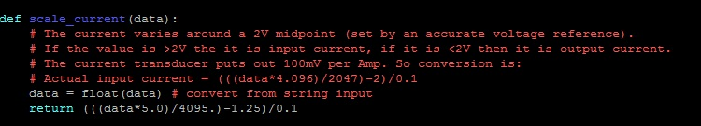

# Slave unit - Hardware

Here the full technical design is explained along with design choices made.

This is based upon the ATMEGA329-PU microcontroller, using the Arduino bootloader and IDE for code development.

There are two versions of the slave unit – a unit to measure a single battery (called “1CHANNEL”) and a unit with 4 channels to measure multiple batteries (called “4CHANNEL”).

There are slight differences between the two designs, which will be noted when applicable.

## Documentation_Prototypes_full.jpg

The two different versions.

## Slave hardware overview

This is a block diagram of the main parts on the slave units. A 1 channel device is shown here – the four channel device has (as you might have guessed) 4 channels, but the rest of the hardware is the same.

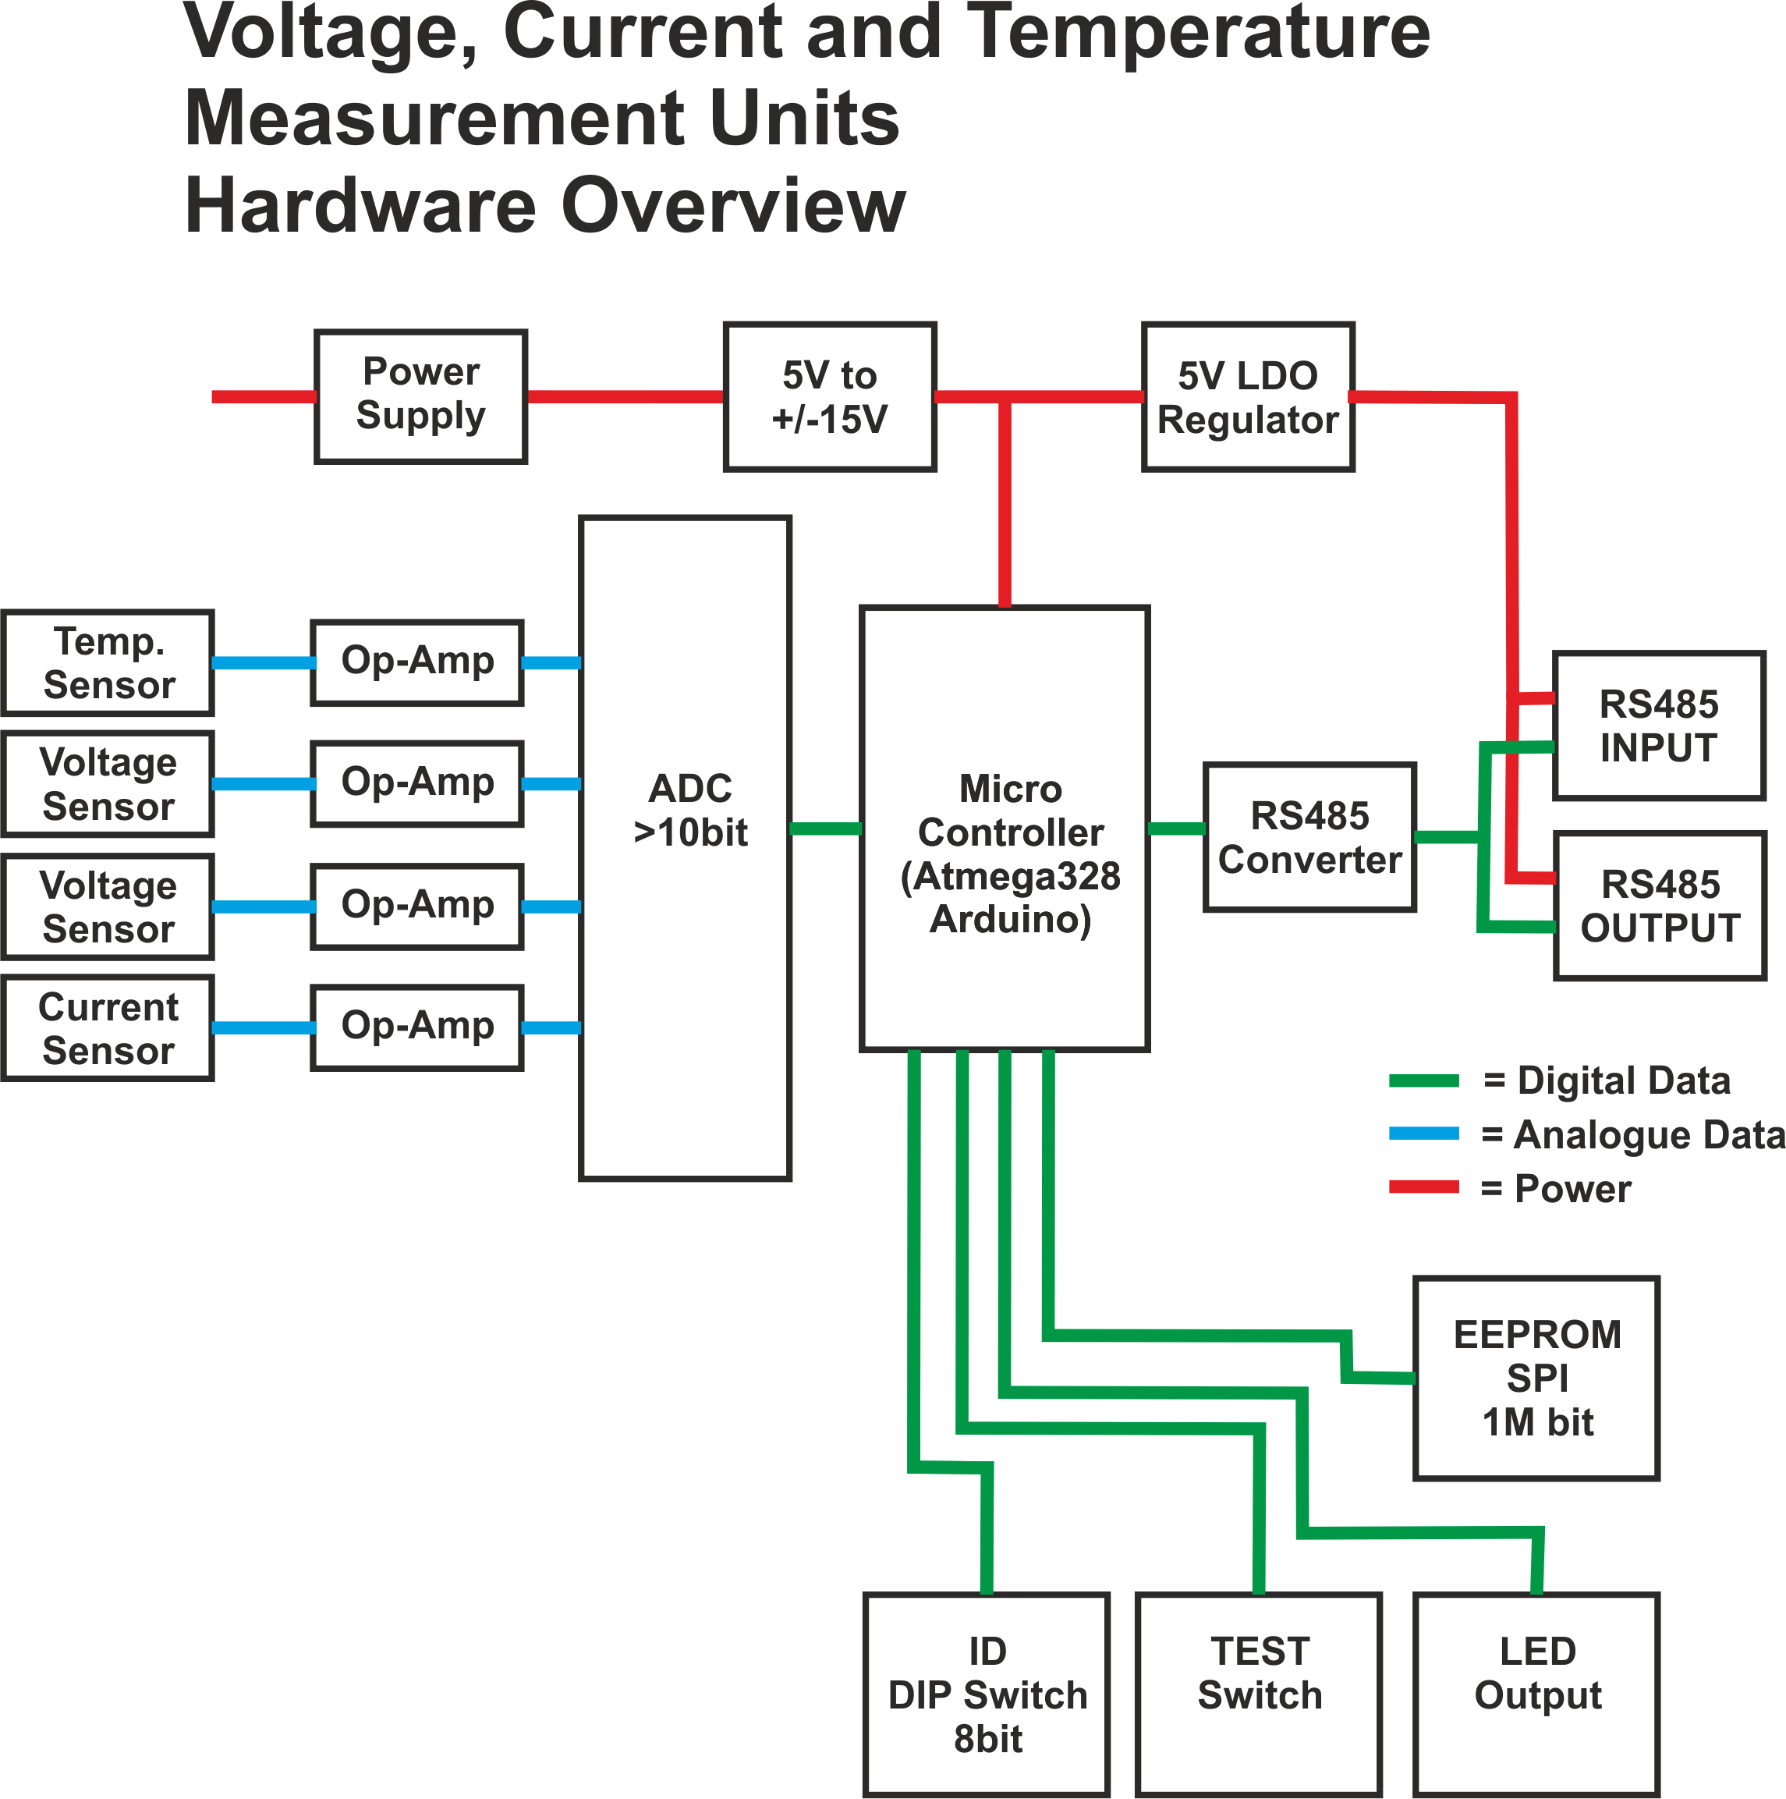

## Microcontroller

These are all based upon the ATMEGA328-PU (<http://www.atmel.com/Images/doc8161.pdf>) which is an 8-bit microcontroller with 32Kbyte programmable flash memory, 2K SRAM and 1K EEPROM.

This has been programmed with the Arduino ([www.arduino.cc](http://www.arduino.cc)) bootloader and the Arduino IDE (Integrated Development Environment) has been used for programming.

There are lots of examples, large user-base, fast to develop, potentially useful for open-source projects.

Clock speed is 16MHz. The maximum I2C is 100kHz (without changes to the Arduino IDE).

There may be issues with speed of data transfer, although it should be easily powerful enough for this application (as ADC is handled separately).

Programming of the slave unit is done via an FTDI programming cable (<http://www.ftdichip.com/Products/Cables/USBTTLSerial.htm>). There is a 6-pin 1x6 socket for this.

The pins are:

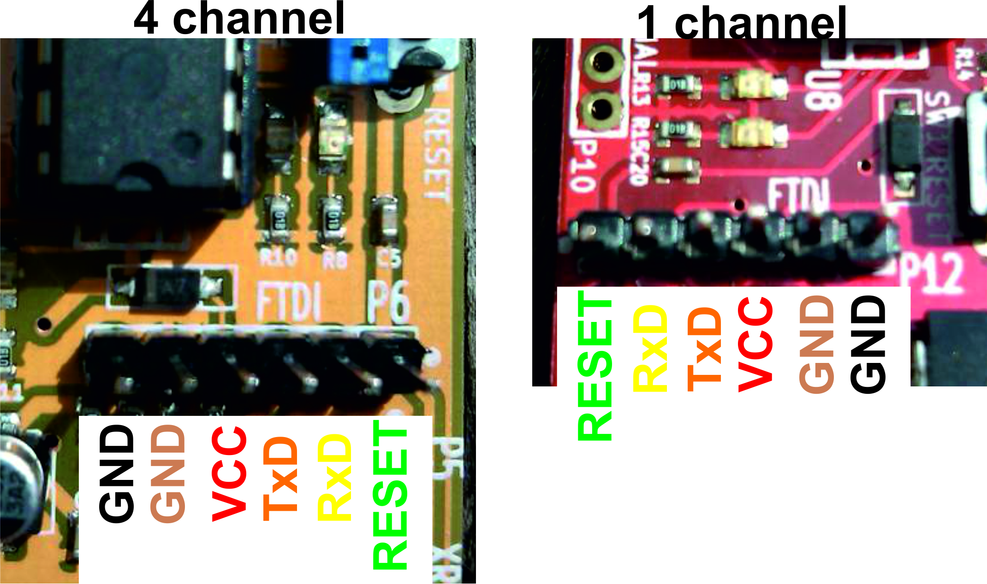Programming can also be done via an ISP (In Series Programmer), which has a 6-pin 3x2 socket.

The pins are:

## Documentation_ISP.jpgSensors

The slave unit must measure three different parameters – current, voltage and temperature.

### Current Sensor

Hall-effect sensors will be used as they are non-intrusive, fail safe and can be retro-fitted. Split core devices can be used for higher currents.

The output is a voltage which is proportional to the current flowing.

The majority of these devices require a +/-15V dual supply – hence we must supply that to the sensor (discussed in the power supply section).

The final choice of hall-effect sensor will depend upon the current range to be measured.

They are manufactured by a number of different companies including LEM and Honeywell.

0-3A: LEM HX 03-P/SP2

<http://uk.rs-online.com/web/p/current-transducers/4358684/>

0-50A: Honeywell CSCA0050A000B15B01

<http://uk.rs-online.com/web/p/current-transducers/7660129/>

### Voltage Sensor

The specifications are that the unit must be able to measure DC voltage level, up to 60V DC (for 48V battery banks).

This can be easily done using a potential divider. Potential divider can be calculated to give the correct conversion range.

A 5.1V zener diode to protect against potential over voltage.

An operational amplifier is required as a buffer (unity-gain) and filter between the signal and the analogue to digital converter (ADC) input (discussed later).

The maximum input to the ADC is 5V so we must calculate the divider circuit to ensure the output does not go above 5V for our input range.

A standard 10K resistor is used as the bottom resistor in the potential divider circuit.

For example:

To measure up to 60V DC:

Keeping within the 5V maximum input and using a 10k resistor as Ra, the potential divider will be comprised of Ra = 10k and Rb > 110k (where Vout = Vmax x(Ra /(Ra +Rb)), hence 5 = 60 x (10/(10+110))). It would be best to have some headroom, in case of any higher voltages, so using a value of Rb = 150k would be best, giving a voltage range of up to 80V.

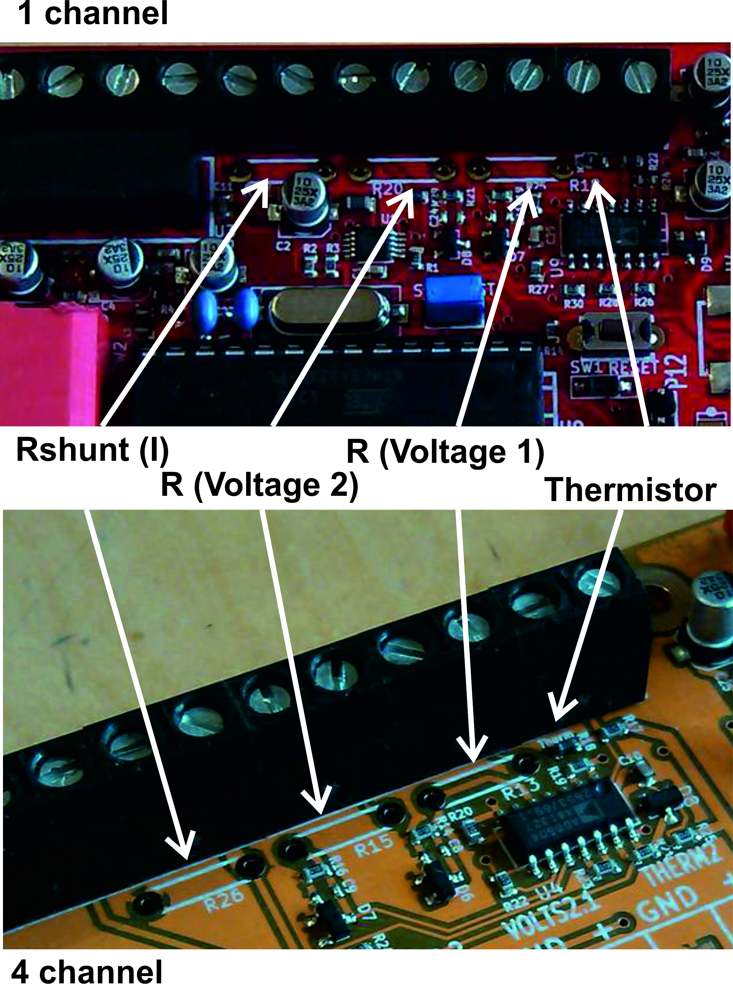

### Temperature Sensor

A thermistor is used as part of a potential divider circuit with an accurate and stable reference voltage.

* Low cost.
* Good accuracy (within 1-2C).

A 10K thermistor is used to record the temperature. The thermistor is put as half of a potential divider, with a 10k precision resistor and a precision voltage regulator to supply the potential divider.

The thermistor output must have the correct interpolation applied so that the temperature reading is accurate. There are standard Arduino libraries to perform this conversion.

The thermistor must be thermally bonded to the unit/device under test.

There is also a connection for a PCB based thermistor, which can be used to measure PCB or ambient temperature.

## Operation Amplifier

An operational amplifier is used to buffer the signal from the transducer to the ADC. The ADC consumes current when performing a conversion. This can affect the signal (such as when a potential divider is used) hence an operational amplifier is used to supply the current required, while having very high input impedance for the signal.

Each channel will need a buffer op-amp, hence a quad op-amp package is used.

Must be good quality, linear, rail-to-rail, single supply units with very low off-set.

There are many op-amps available. The Analog Devices AD8604 (<http://www.analog.com/static/imported-files/data_sheets/AD8601_8602_8604.pdf>) was used in the prototype, but has a standard pin output so other can also be used.

## Analogue to Digital Converter (ADC)

The analogue to digital converter is vital to the accuracy of this unit.

The ATMEGA328 has a 10-bit precision internal ADC which, at 5V Vref, gives a resolution of 5V/1024 levels = 4.88mV. This is OK, but not good enough for measuring small current variations from the hall effect sensors.

Each additional bit of precision improves the resolution and hence accuracy of the readings. The ADC must be >10bit precision, to give accurate results.

Differential inputs use two ADC channels to give better resolution and fewer problems with ground noise. But, this would mean using twice the number of ADC ICs, hence in these designs on single-ended measurements are used.

### ADC for 1 Channel unit:

The ADS1015 (<http://www.ti.com.cn/cn/lit/ds/symlink/ads1015.pdf>) 4 channel 12-bit ADC is used for the 1 channel slave units. This is a relatively low cost unit.

This uses an I2C interface to communicate to the microcontroller.

The sample rate is 3.3k samples per second.

The resolution is actually 11-bits as 12-bits are only available when the device is used in differential input mode.

The I2C bus on the Arduino runs at 100kHz by default. The Arduino can run up to 400kHz but requires changes to wire.h.

Link: <http://forum.arduino.cc/index.php/topic,16793.0.html>

This change was implemented. The maximum I2C clock speed is 400kHz on the ATMega328.

This increased the data speed by around a factor of 2.

### ADC for 4 Channel unit

For the 4 channel unit a higher specification ADC is used. This is much higher cost.

The AD7490 (<http://www.analog.com/static/imported-files/data_sheets/AD7490.pdf>) 16 channel 12-bit ADC is used in the 4 channel unit.

This uses an SPI interface to communicate to the microcontroller.

The sample rate is 1M samples per second, so much higher than the ADS1015.

## Power Supplies

The logic and main components of both slave units runs at 5V DC. The hall-effect current transducers may require +/-15V. The thermistors and ADC require an accurate voltage reference. Hence there are three main power supplies on the slave units.

### 5V regulator

The input voltage will be in the range of 7-60V, depending upon the application. Ideally the unit should be powered by the battery bank under test, although power can be provided externally.

A good quality and stable linear regulator could be used, as long as the current draw is not too high (otherwise some type of switching regulator could be used).

Maximum current draw (approx):

* 20mA microcontroller,
* 20mA ADC and op-amps,
* 600mA for 3W DC/DC converter

Total: 640mA, so need a 1A regulator.

The slave units developed here can use either an LM7805 (<http://www.fairchildsemi.com/ds/LM/LM7805.pdf>) which is a 1A 5V linear regulator for input voltages up to 35V DC. This is low cost, but inefficient, especially for higher input voltages.

Or the slave units can use an AP1512/A (<http://www.diodes.com/datasheets/AP1512_A.pdf>) which is a 2A DC/DC converter IC. This requires a high speed diode and inductor, as shown in the circuit diagram. This would be much more efficient for higher voltages and can cope with 60V input.

The 5V power supply section has been designed to use either of the regulator mentioned, or a 5V supply can be fed directly, if available.

### +/-15V regulator

NOTE: On this version the + and – 15V supplies are incorrectly marked – they should be reversed.

This is a small DC/DC converter, required for some versions of the hall-effect sensors.

Each sensor requires (up to) 45mA, so power required at 15V is 0.67W for each sensor. So we need a 2W or greater device, to power all three current sensors, or a separate supply could be used for each sensor.

Many different versions are available. They are relatively high cost. Here are some available versions:

* Murata NMA0515S
* TRACO TMA0515D
* XP Power IH0515S

The circuit board has been design to fit the standard SIL package which will fit with either the 1W or 3W versions.

### Reference Voltage

An accurate voltage reference is required for the ADC and for the thermistors.

This is provided by the REF3025 (<http://www.ti.com/general/docs/lit/getliterature.tsp?literatureNumber=sbvs032f>) from Texas Instruments. This is a CMOS voltage reference.

## Data output

The output data from the Arduino will be TTL serial at 5V voltage levels. This will work for short range communications, but other outputs are required. One requirement was an RS485 compatible output.

Data is sent at 115200baud 8 bits No parity 1 stop bit (8N1).

### Serial

The serial port has +5V, Tx, Rx 0V and can be used as a direct connection to a serial interface.

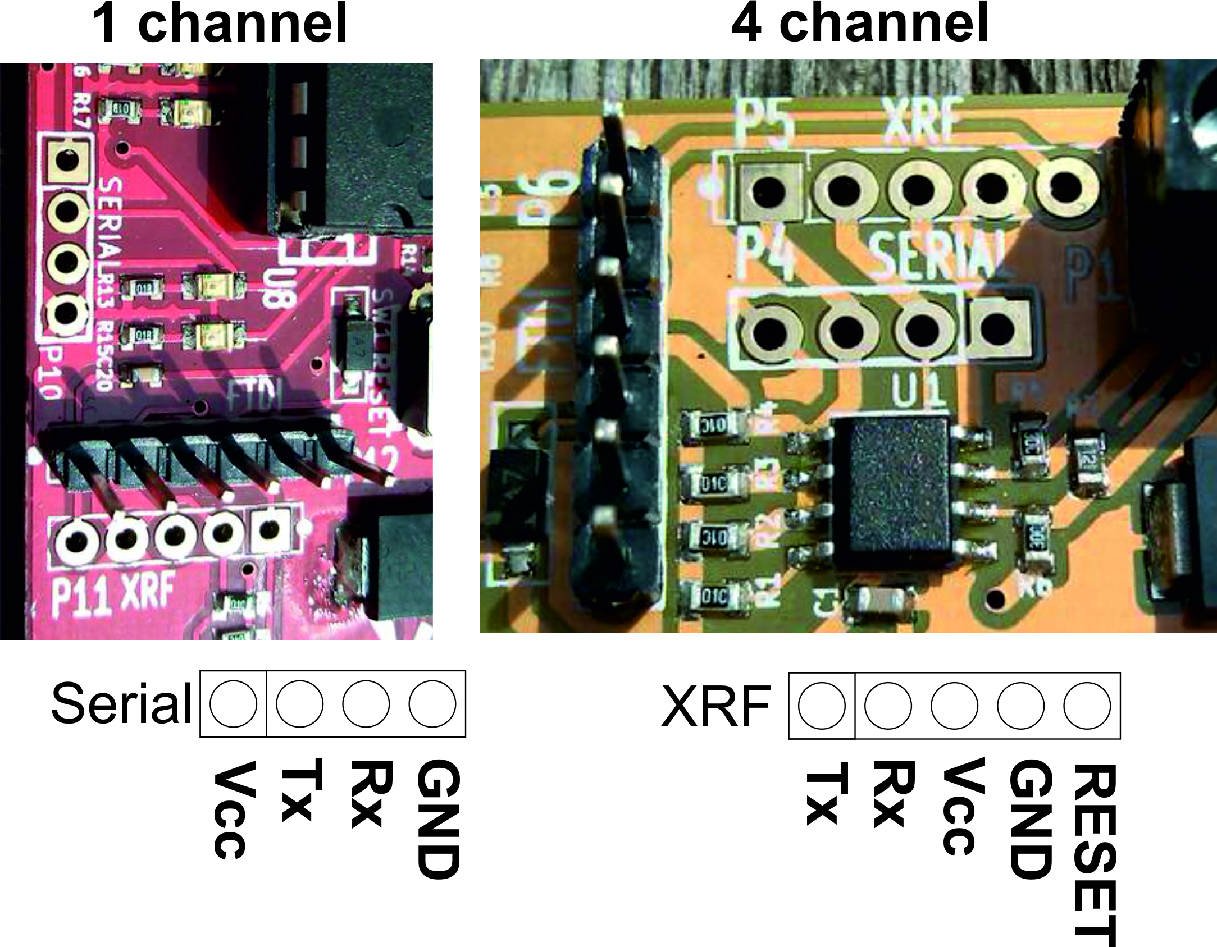

### XRF

For wireless communications, which could be useful in some environments, a standard connection for the XRF low-cost wireless module (<http://shop.ciseco.co.uk/xrf-wireless-rf-radio-uart-rs232-serial-data-module-xbee-shape-arduino-pic-etc/>) is provided.

This unit runs at 3.3V so would need an XBBO breakout board and voltage regulator.

This can be used as a drop-in replacement for a serial connection, which may be useful in some applications. The connection diagram is above.

### RS485 output

RS485 is an industry-standard for the signal voltage levels designed for high-noise industrial environments. This defines the physical layer (not the communications protocol (which uses MODBUS)). RS485 consists of three lines A, B and Ground. A will be an inverted version of B. Ground may not be required.

The output from the Arduino will be TTL serial. This must be converted into a correct RS485 signal. This is performed with an RS485 converter IC.

A half-duplex RS485 converter IC is used: the MAX485 (<http://datasheets.maximintegrated.com/en/ds/MAX1487-MAX491.pdf>) from Maxim.

This is a half-duplex device (so data can either flow in one direction or the other, never both at the same time). A transmit enable pin is required which is set whenever data is transmitted from the slave to the master. This is a digital pin from the ATMEGA328.

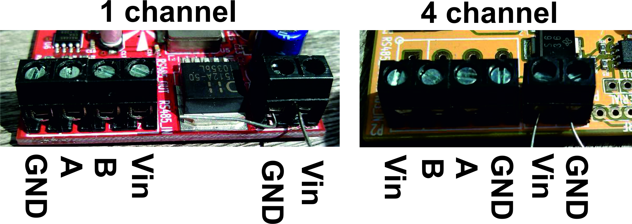

## ID switch

This sets the ID for the board. This is an 8-way DIP switch to make it easily field programmable. This gives 256 different addresses. It uses 8 digital channels of the microcontroller.

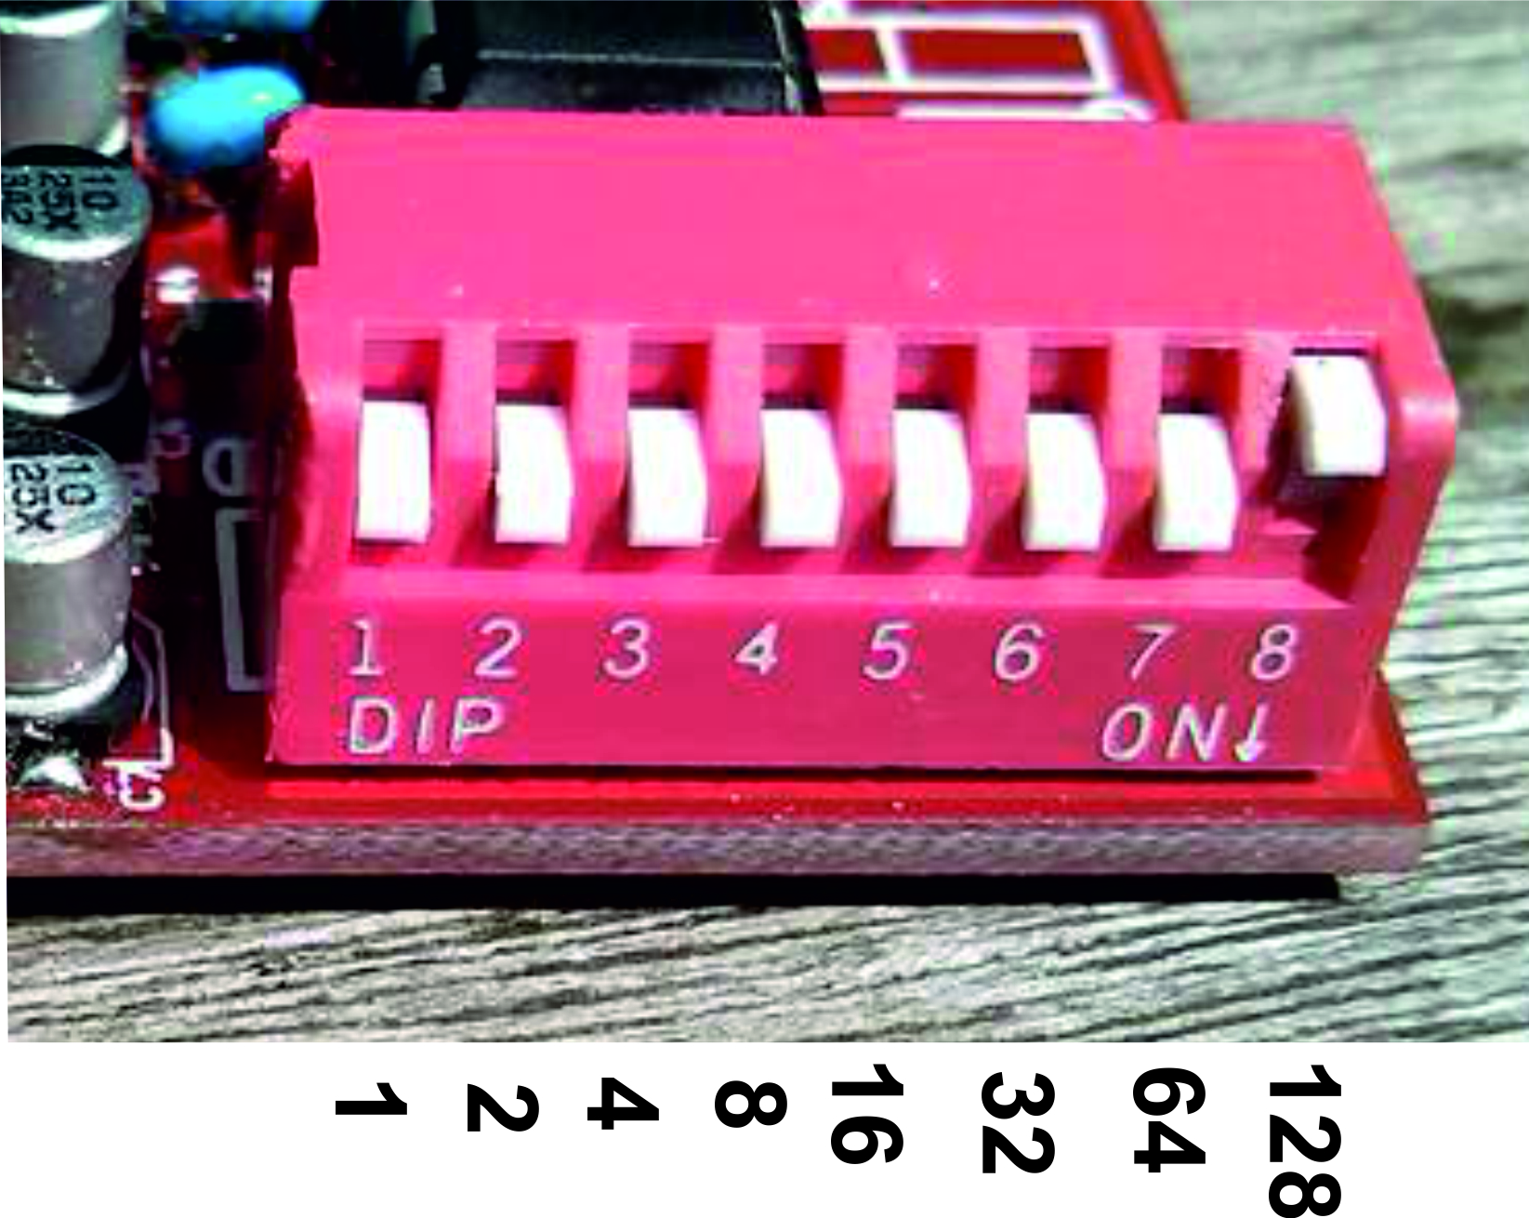

## EEPROM

This has been added for future development. A 1M bit serial SPI EEPROM IC has been added to enable remote re-programming of the ATMEGA328.

This has enough space so that two versions of the 32K byte code can be loaded. The ATMEGA328 can be programmed to read one version, while the other version can be altered via remote serial programming.

Due to the fact that the SPI is also used for the 4 channel salve unit a jumper pad is used to distinguish between the two versions. This is labelled K1 and should be connected as follows:

***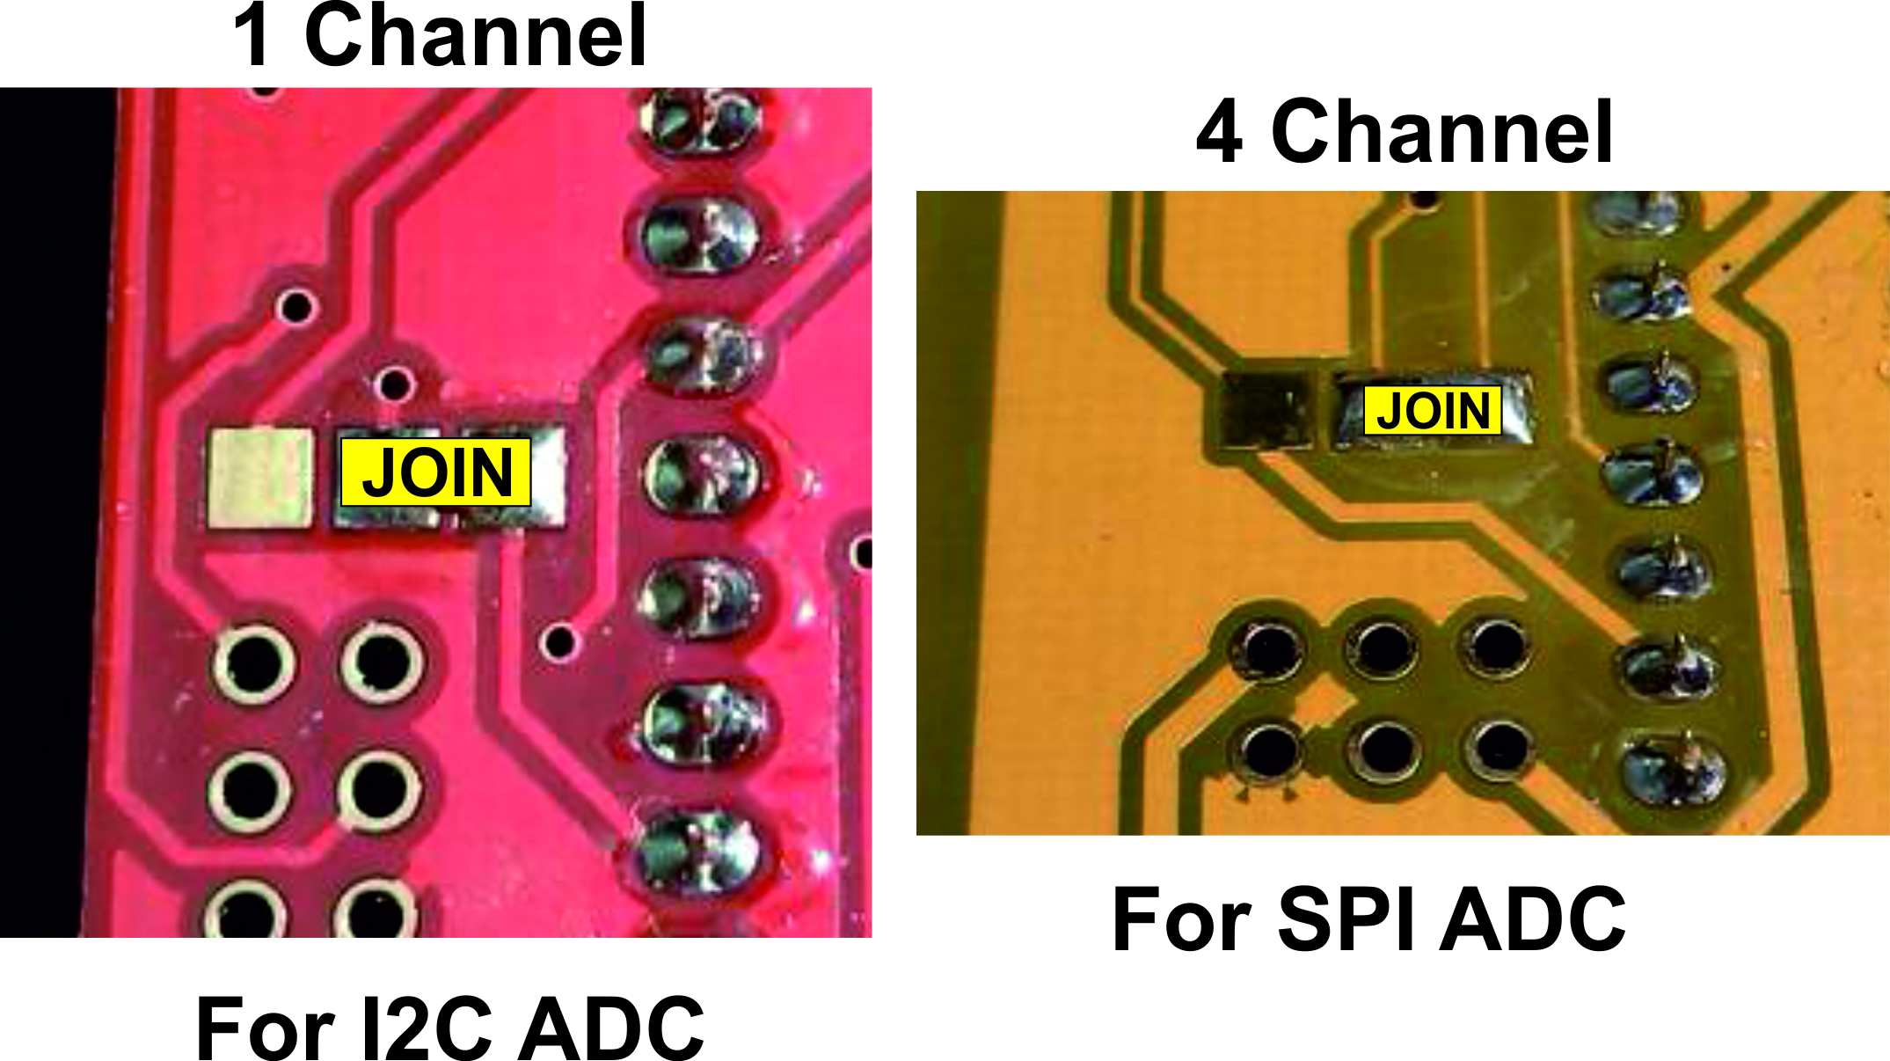*Note: This feature is not yet implemented and is for future reference.**

## Test Switch

To put the slave unit into test mode a simple jumper pin is used. With a jumper applied then the data output will be written to the serial port.

Without a jumper pin then the slave unit will only respond when a MODBUS request is made.

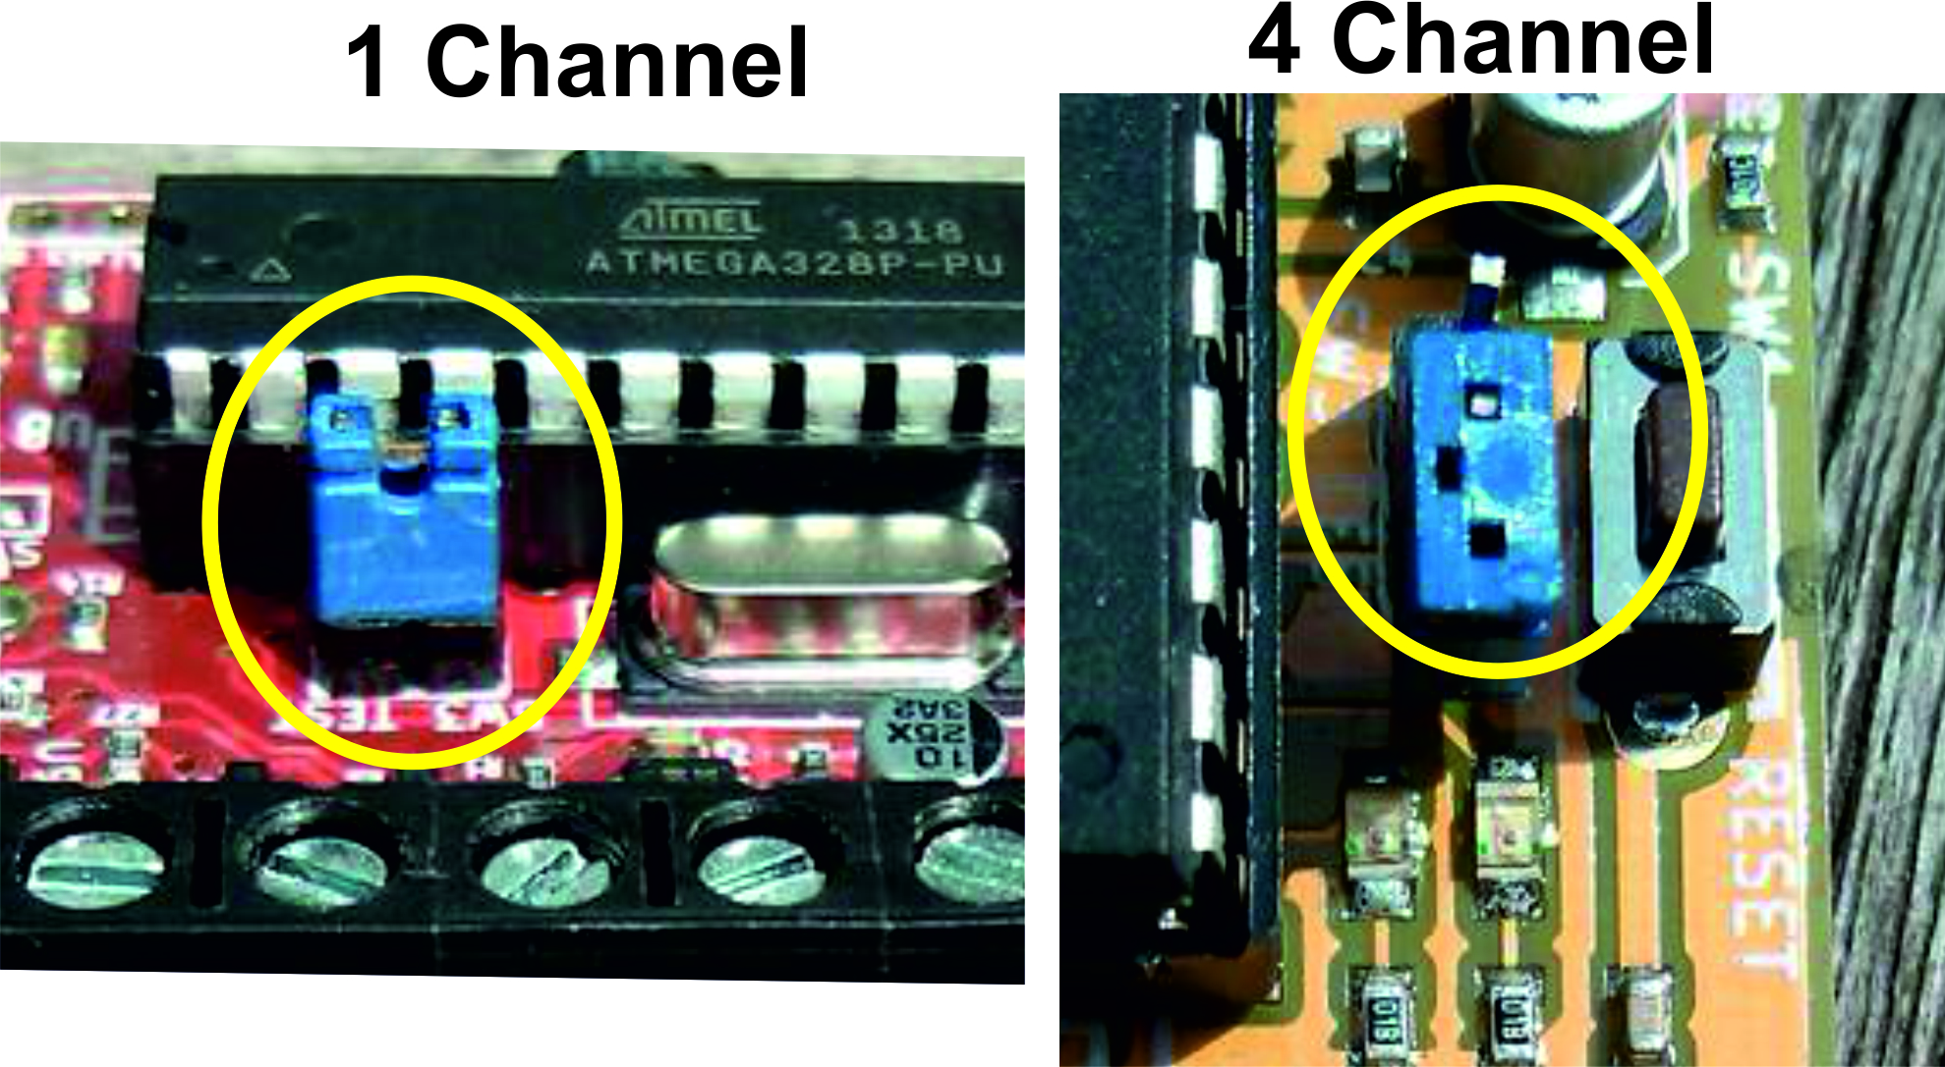

## Output LEDs

There are four status indicators LEDs.

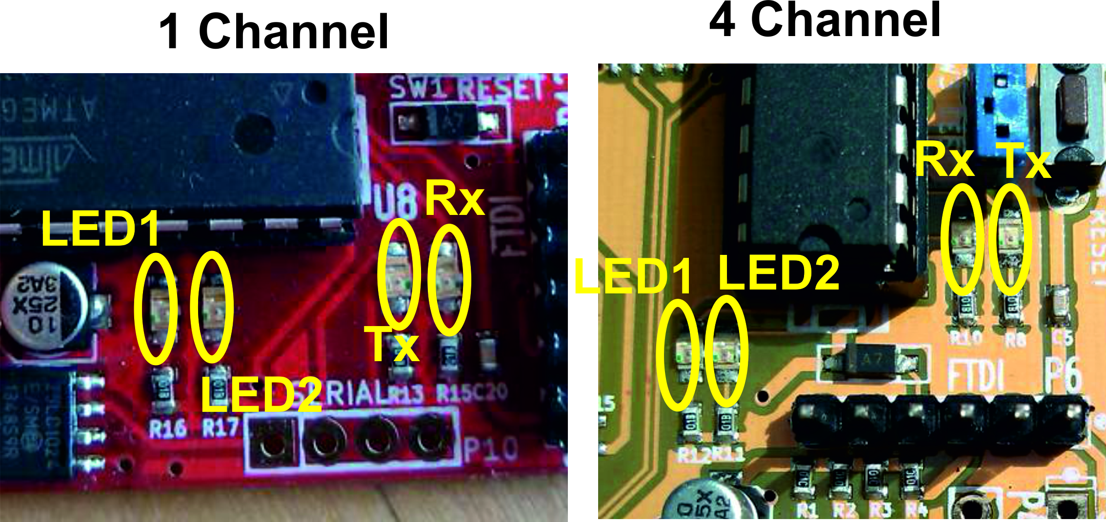

Tx and Rx both have LEDs, to show when they are active.

LED1 is a ‘heartbeat’ LED and shows that the micro-controller is running correctly. It flashes once per second.

LED2 shows when data is written to the serial port.

## Upload Arduino code to slave unit

To upload the microcontroller code to the slave unit we can use the Arduino IDE.

Note: This assumes basic knowledge of using the Arduino IDE and uploading code using the Arduino bootloader.

Download and install the latest version of the Arduino IDE (<http://arduino.cc/> ).

Download the latest version of the software from the GitHub account (\*\*\*\*to add\*\*\*).

Download the simple-MODBUS library (<http://code.google.com/p/simple-modbus/>) and upload to your sketchbook.

Use an FTDI USB-Serial cable (code: **TTL-232R-3V3** available here: <http://www.ftdichip.com/Products/Cables/USBTTLSerial.htm> along with other places).

Plug in the FTDI cable:

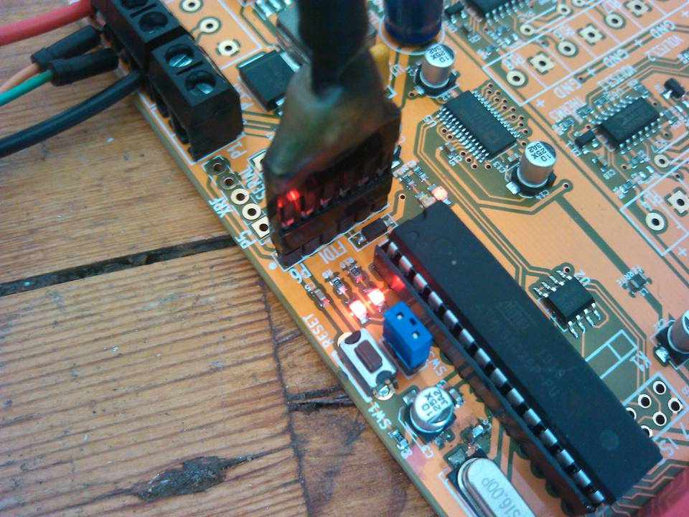

Upload code to the device, using the COM port for your FTDI cable.

There should be no errors.

Put the slave unit into test mode (using a jumper) and view the output on a serial monitor.

Within the Arduino code there is the option to set if the slave unit is a 1 channel or 4 channel device. You can also set if the test-mode output is HUMAN (converted into human readable format) or RAW (just shows the 12bit number (0-4095)).

You can also set the thermistor, voltage and current conversion factors. This only affects the human readable output.

## VIt_Arduino_2.jpg

## Test Mode for slave unit

When the test pin is set to low (a jumper placed on the pins), then the output on the serial line will be a raw data output.

The data will start with the ID number and the next numbers will be:

Temp1, Voltage 1.1, Voltage1.2, Current1 (for the 1 channel version)

Or the same thing repeated 4 times for the 4 channel version.

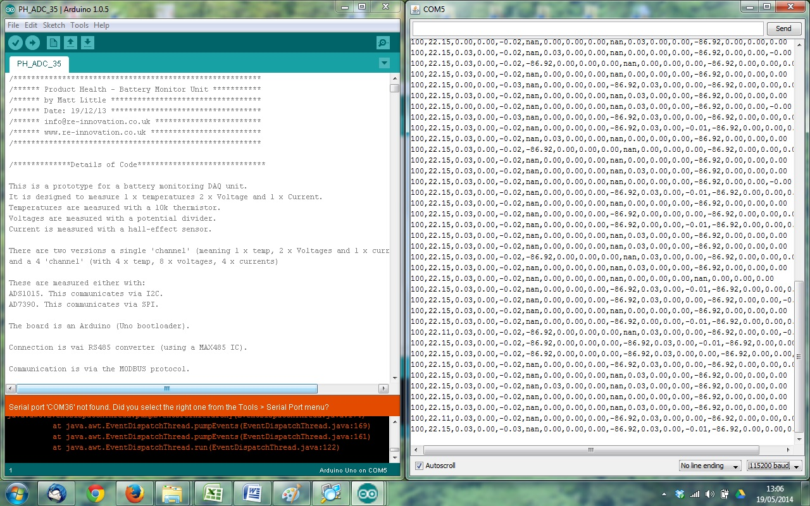

## Slave unit 1 Channel circuit diagram

Designed in KiCAD (<http://www.kicad-pcb.org/display/KICAD/KiCad+EDA+Software+Suite>). Full designs available to download.

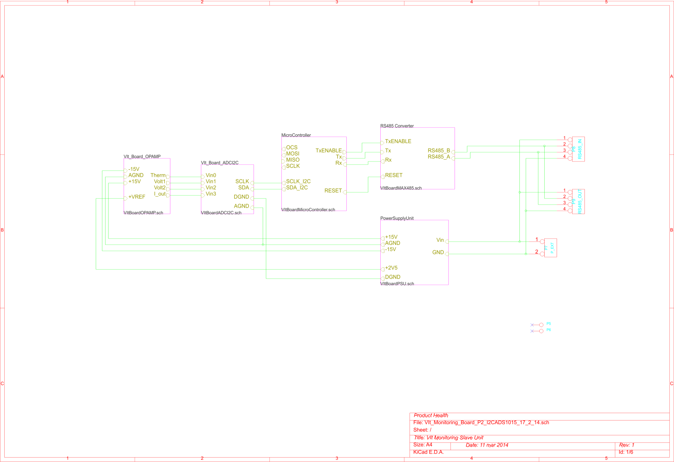

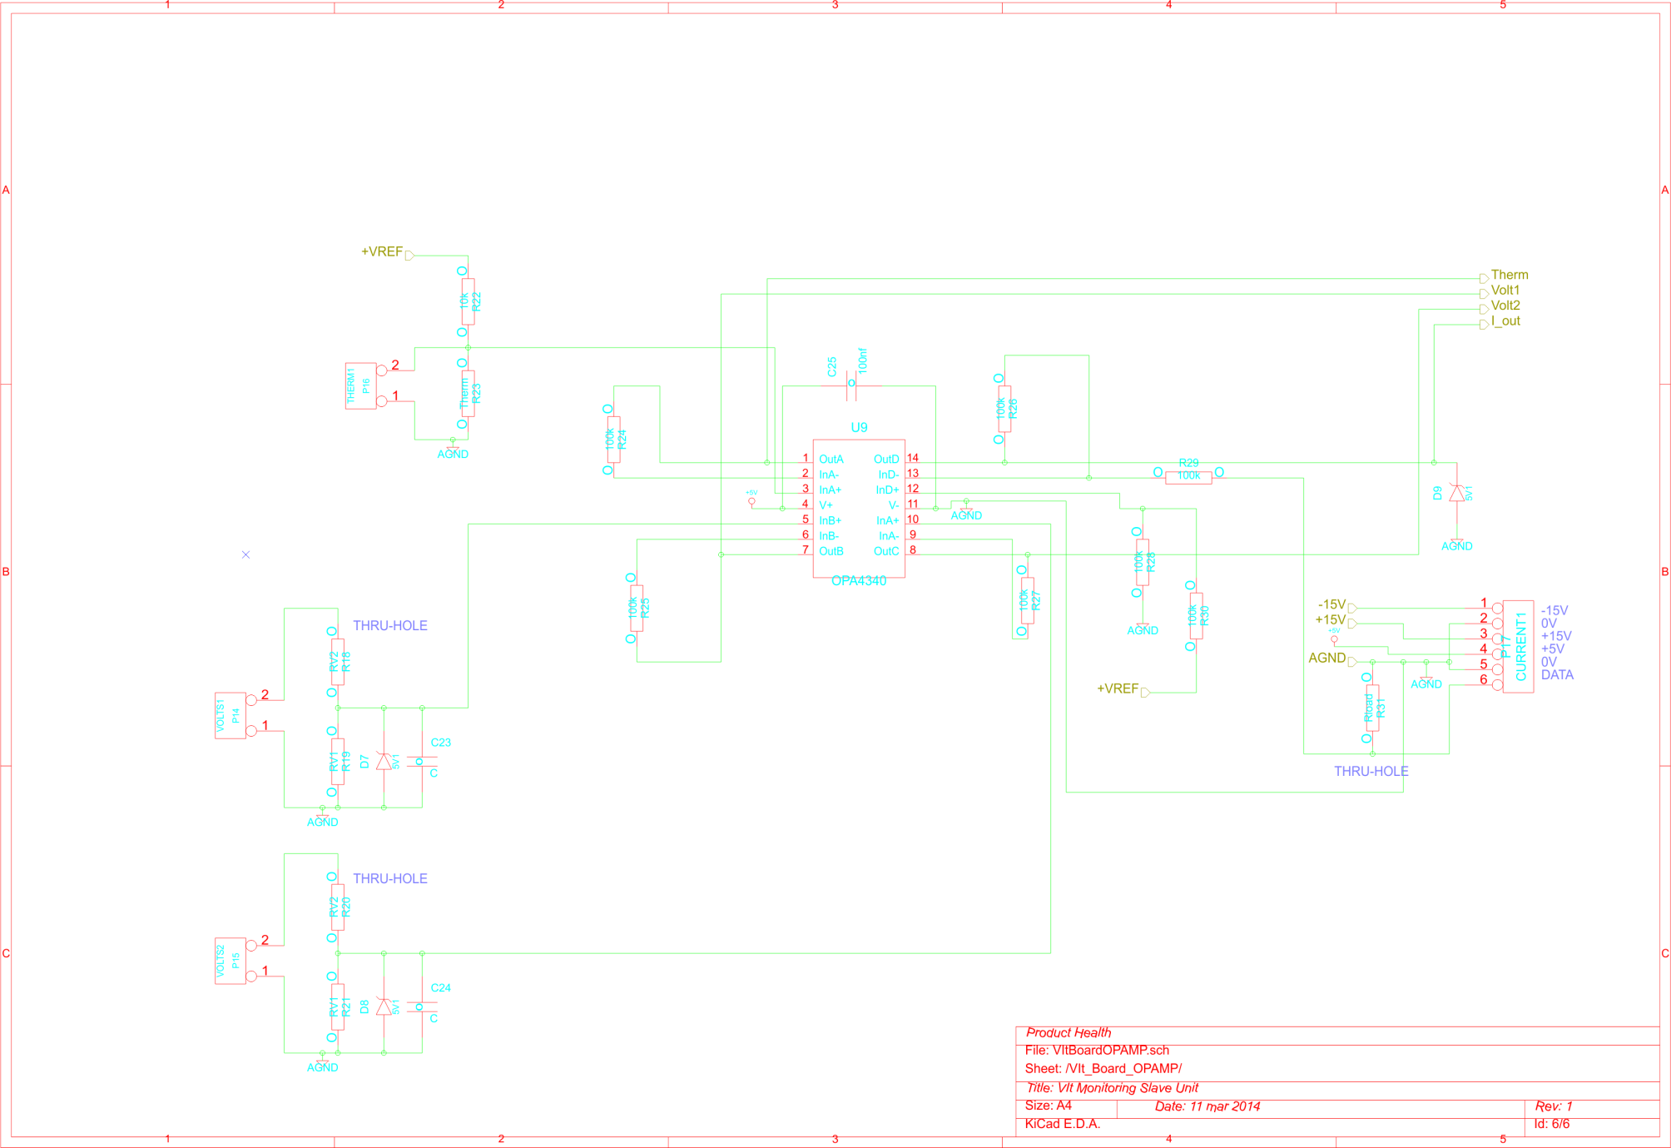

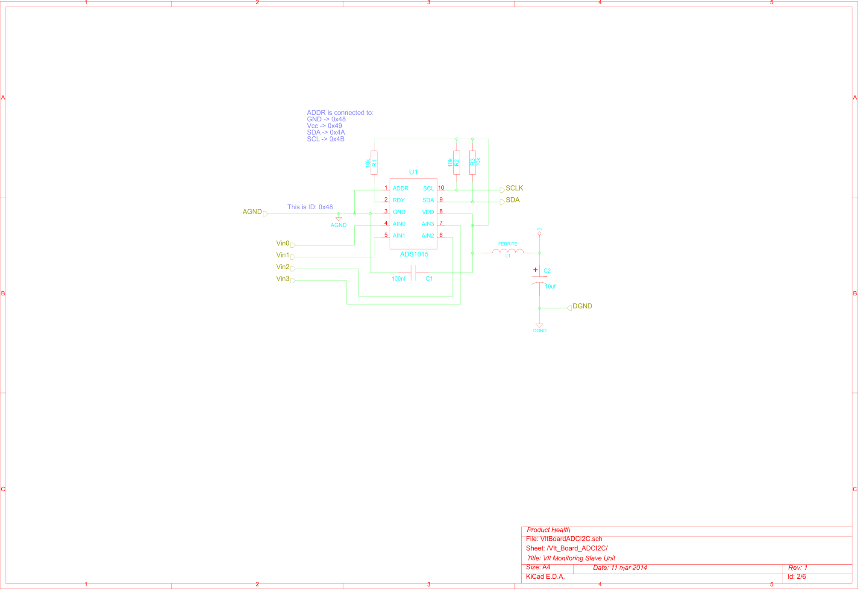

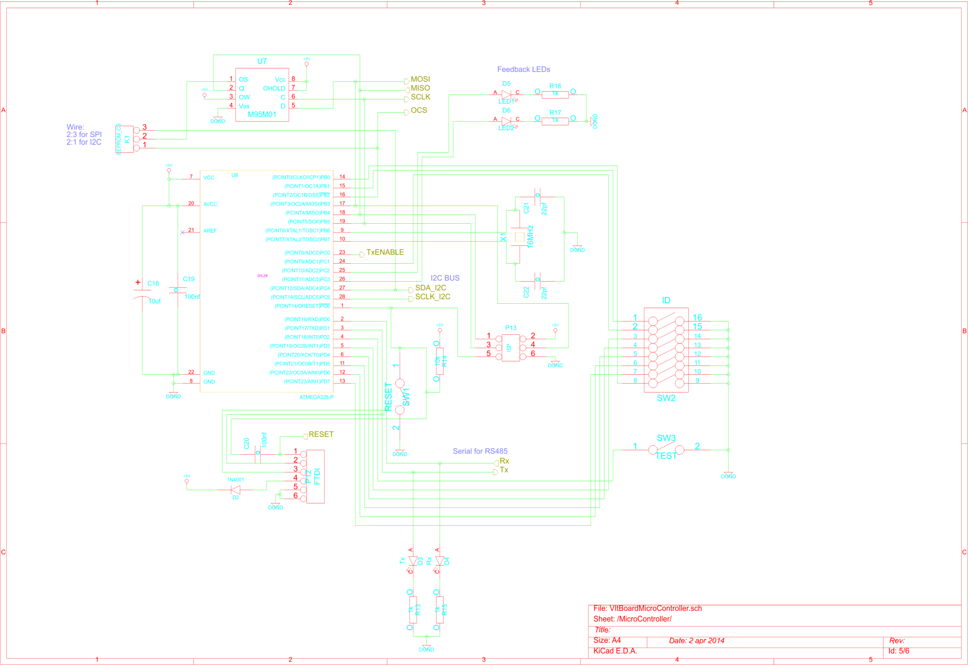

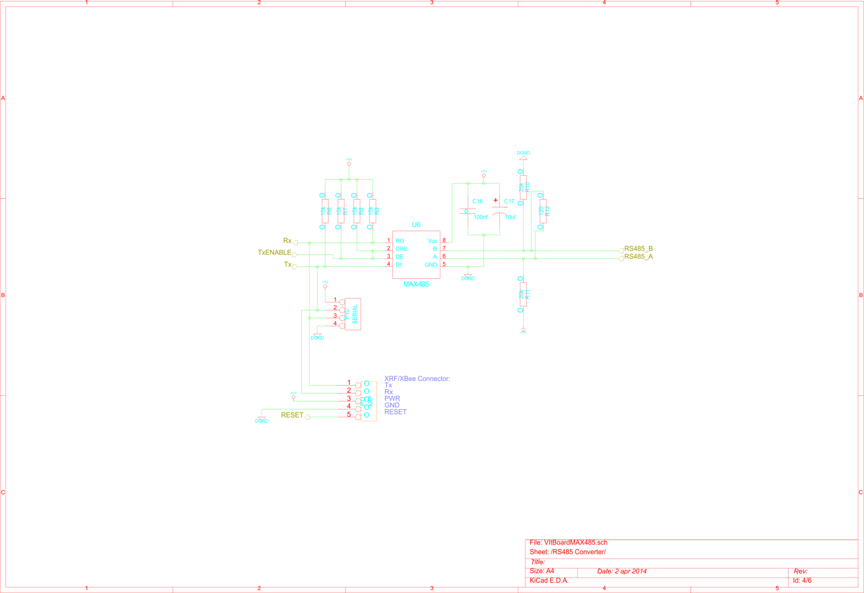

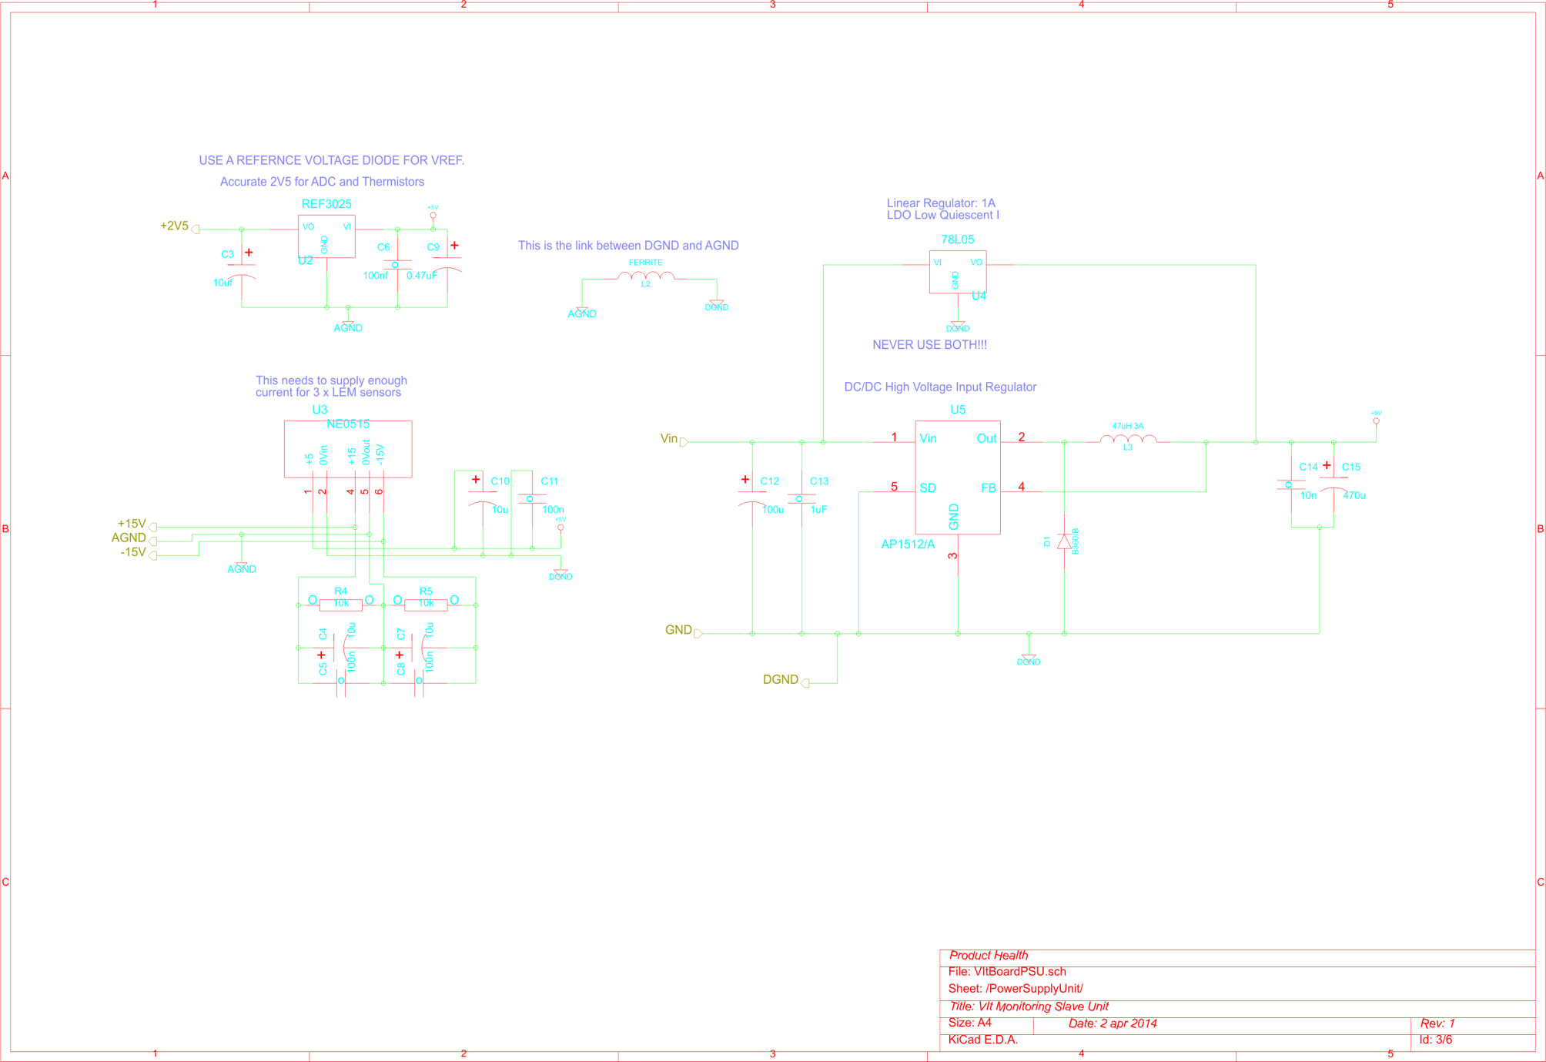

## PCB for the 1 Channel Slave Unit

Designed in KiCAD (<http://www.kicad-pcb.org/display/KICAD/KiCad+EDA+Software+Suite>). Full designs available to download.

Showing the silk screen, the bottom copper and the top copper.

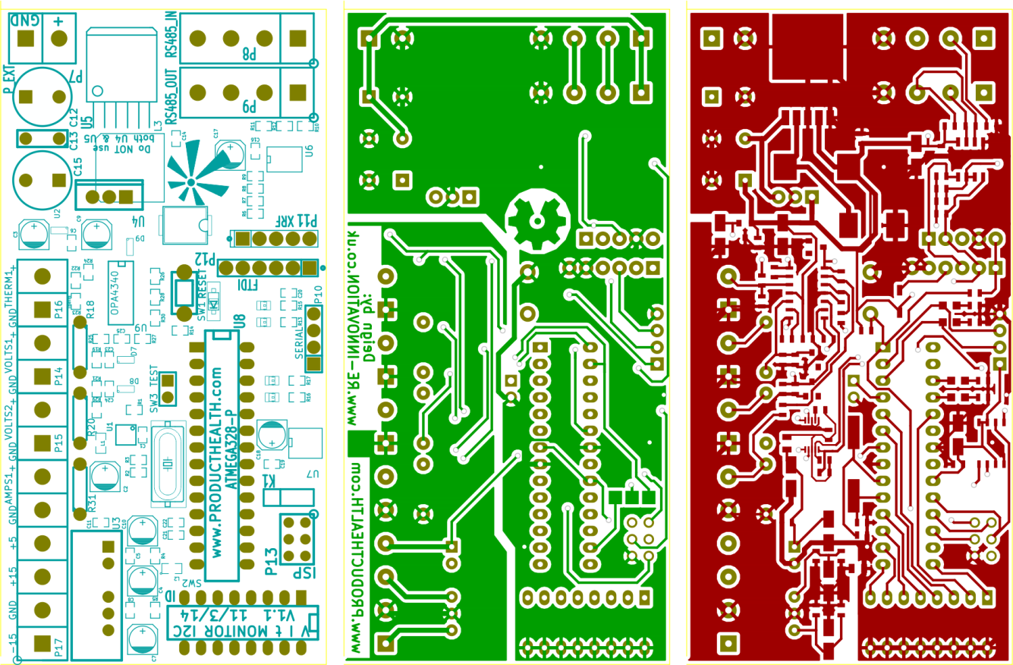

## Parts List for 1 Channel Slave Unit



### Schematic diagram for 4 Channel Slave Unit

Designed in KiCAD (<http://www.kicad-pcb.org/display/KICAD/KiCad+EDA+Software+Suite>). Full designs available to download.

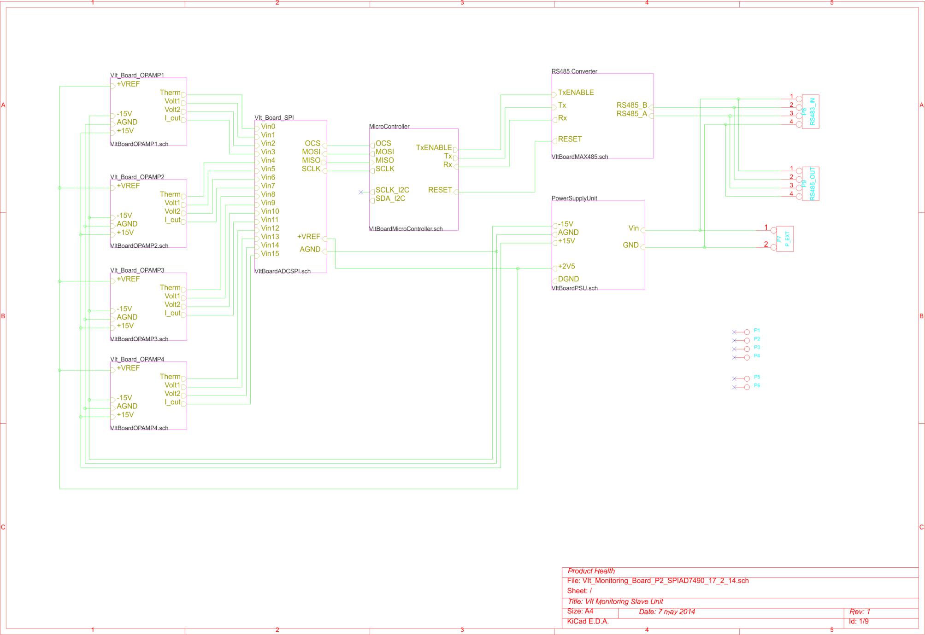

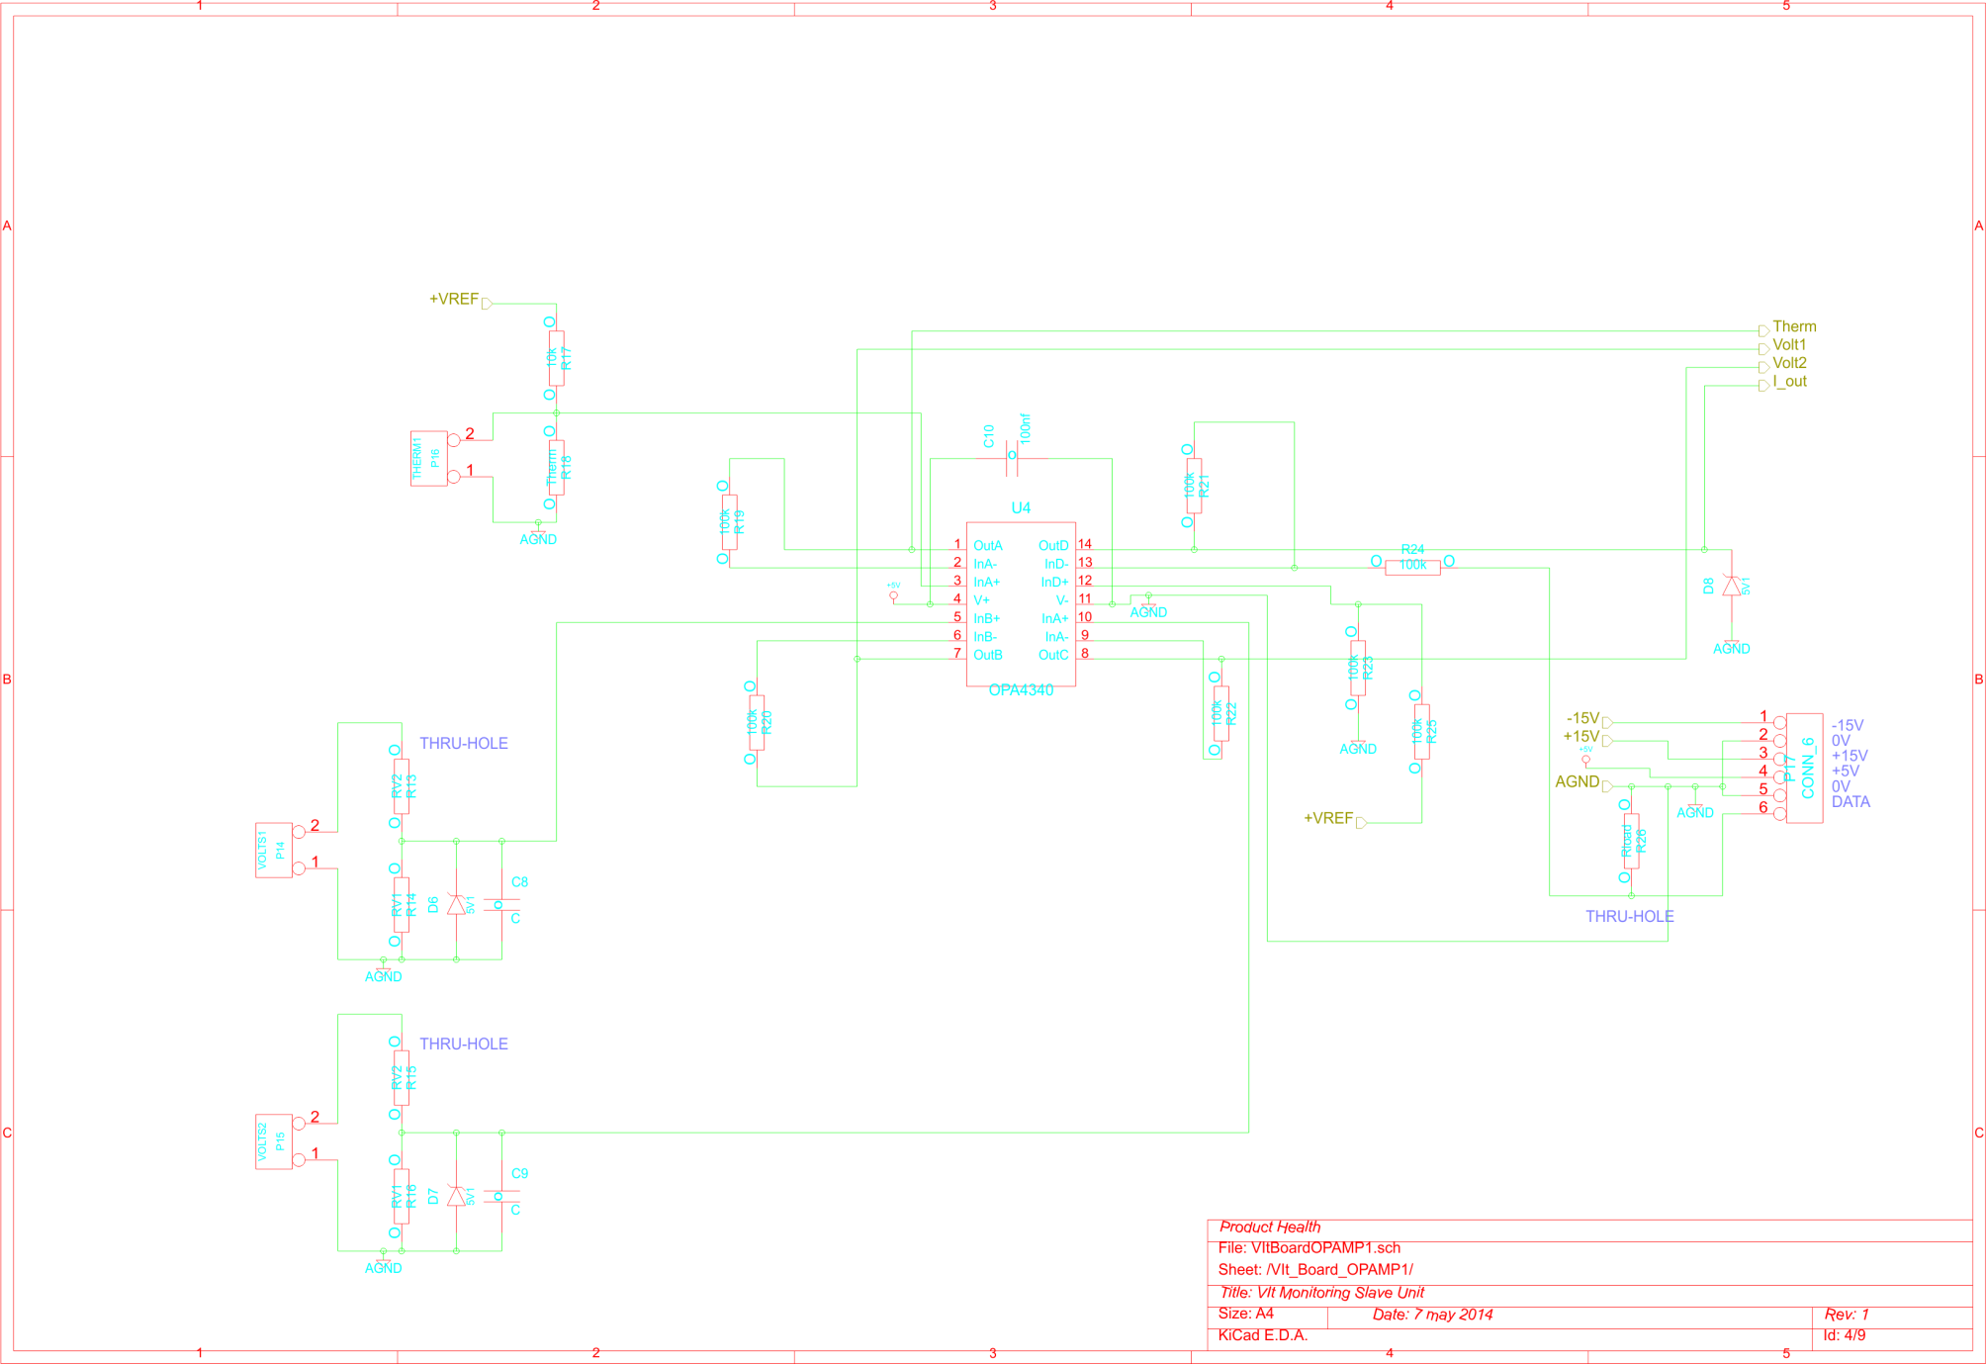

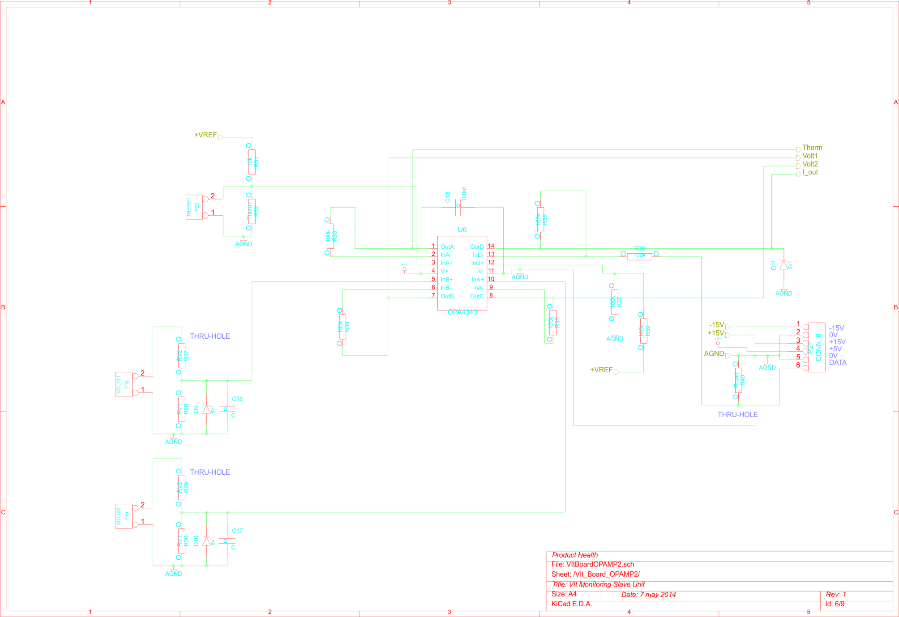

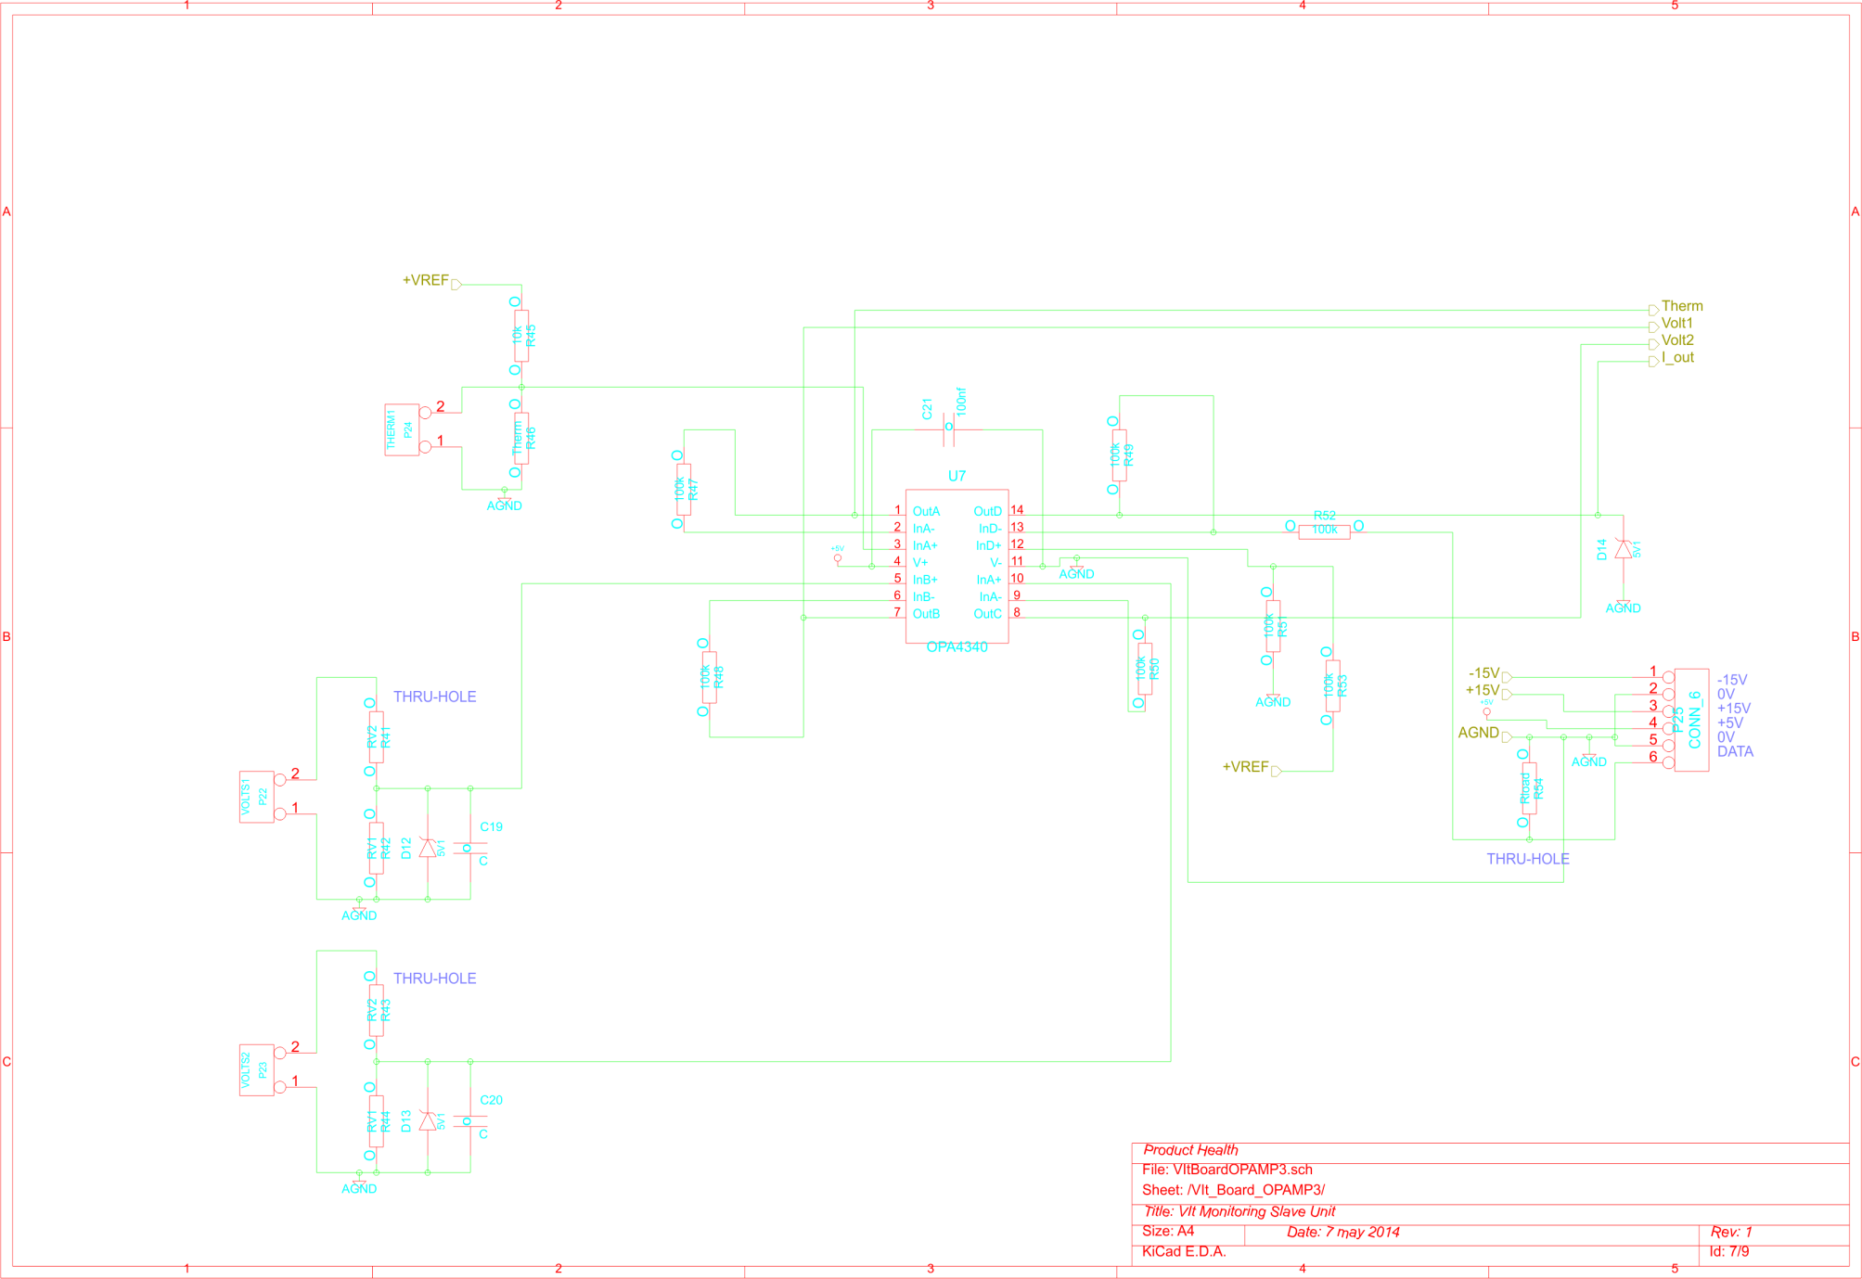

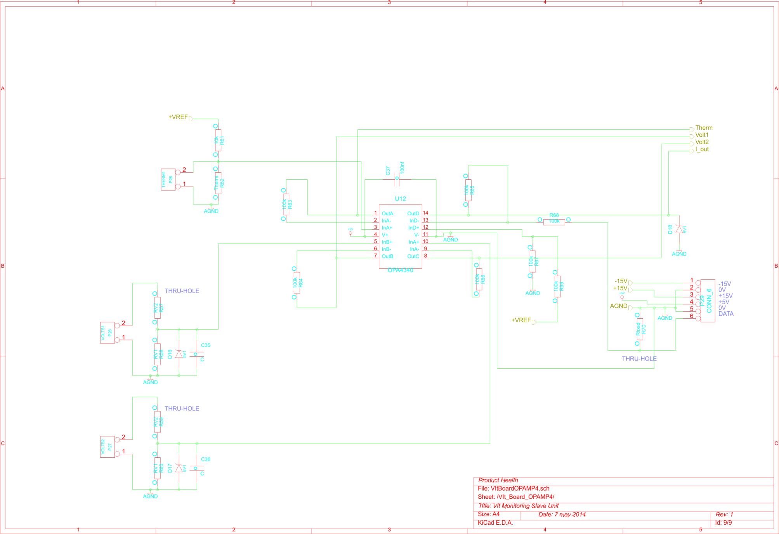

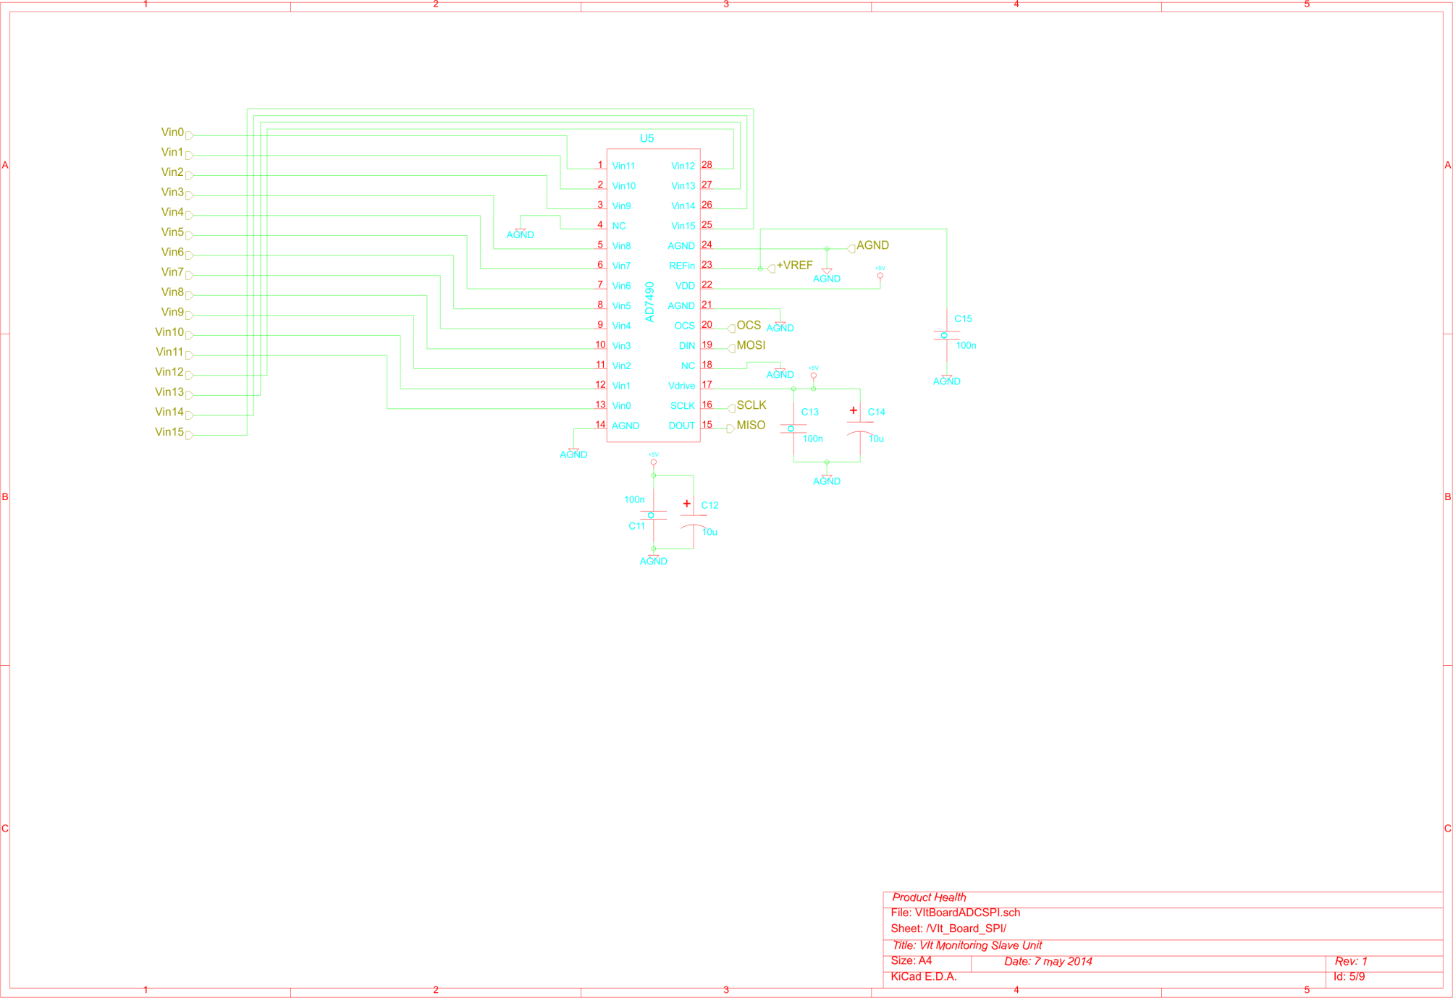







### PCB layout for 4 Channel Slave Unit

Designed in KiCAD (<http://www.kicad-pcb.org/display/KICAD/KiCad+EDA+Software+Suite>). Full designs available to download.

Showing the silk screen, the bottom copper and the top copper.

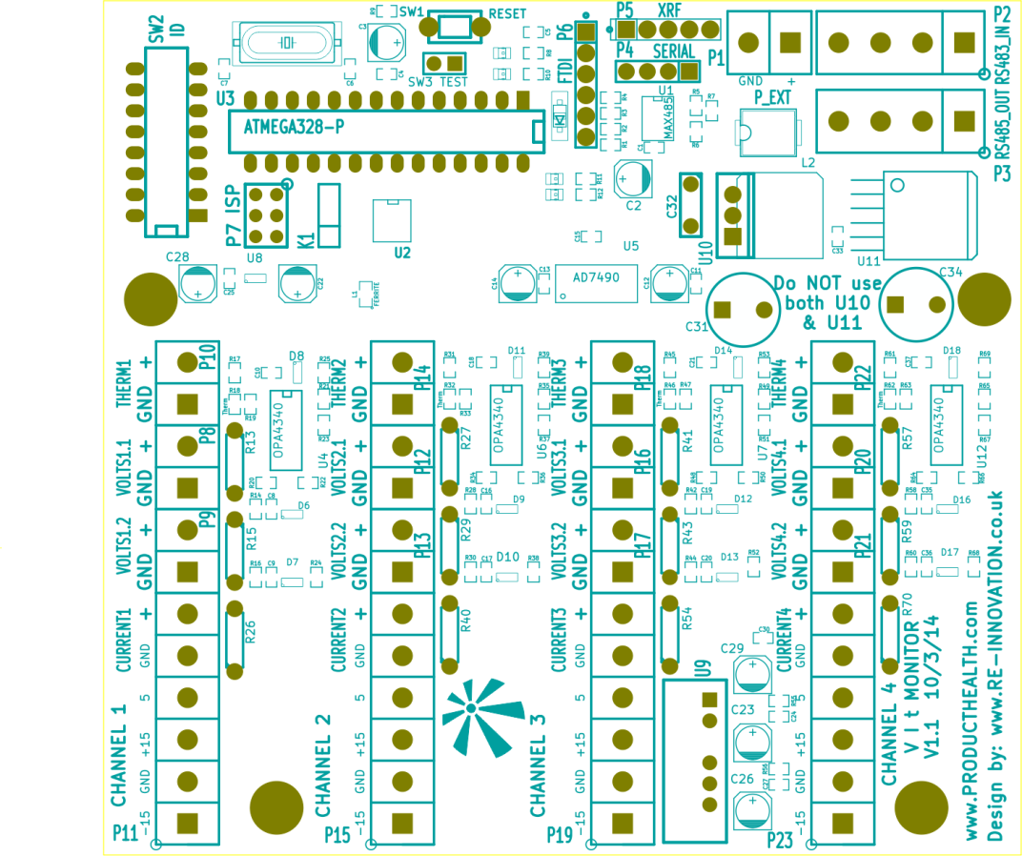

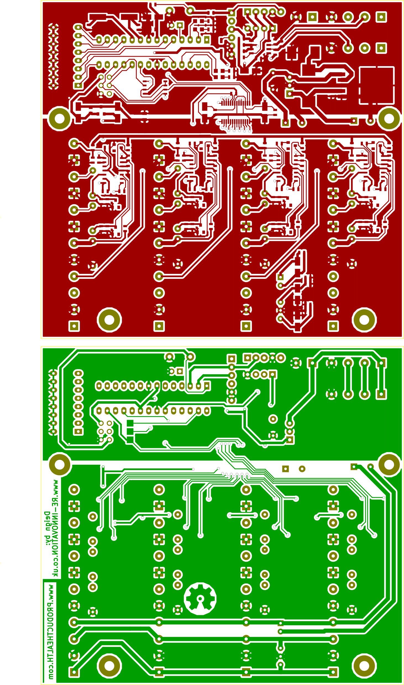

### Parts List for 4 Channel Slave Unit



# Slave unit - Software

The software must be robust and simple but perform a number of tasks:

* Measure all the analogue channels (via the I2C ADC)
* Keep a running average of that data (with an adjustable sample period)
* Respond to MODBUS requests for data

It could also perform some conversion, although this requires the conversion factors to be hard-programmed onto the slave unit. It is best that these conversions are performed on the master unit, but having a conversion

* Convert temperature readings into degrees C (this could be done off-unit)
* Convert voltage readings into V (this could be done off-unit)
* Convert current readings into I (this could be done off-unit)

The software for the Arduino is the same for both 1 Channel and 4 Channel versions. A Definition at the beginning of the program is used to change the version.

## Software flow diagram

This shows the basic structure of the Arduino software:

## VIt Board Arduino Flow Diagram_7_5_14.png

## Communications Protocol

This unit will use MODBUS (<http://en.wikipedia.org/wiki/Modbus>) as the communications prototcol.

MODBUS is a standard industrial serial communications protocol. Initially developed for PLCs. It uses the Master/Slave technique, with up to 247 slaves to each master. This VIt unit is a MODBUS slave, responding to the master, which is the Master unit (a Raspberry Pi).

Each slave has an ID from 1 to 247. This will be the first byte the master sends. A slave will only respond when its unique ID is written.

The master will then send a function code. This tells the slave what to do:

|  |  |  |
| --- | --- | --- |
| **Function Code** | **Action** | **Table Name** |
| 01 (01 hex) | Read | Discrete Output Coils |
| 05 (05 hex) | Write single | Discrete Output Coil |
| 15 (0F hex) | Write multiple | Discrete Output Coils |
| 02 (02 hex) | Read | Discrete Input Contacts |
| 04 (04 hex) | Read | Analog Input Registers |
| 03 (03 hex) | Read | Analog Output Holding Registers |
| 06 (06 hex) | Write single | Analog Output Holding Register |
| 16 (10 hex) | Write multiple | Analog Output Holding Registers |

At the end of every MODBUS message there is a Cyclic Redundancy Check (CRC) which are two bytes used for error detection. The CRC value is calculated by performing logical operations on the data which creates a unique 2 byte code, added to the message.

Data is stored within four different tables, which relate to output ‘coils’ (on/off display units), input ‘contacts’ (switches/sensors), Analog Input Registers (read-only analog sensors), Analog outputs holding registers (analog output units).

This monitoring board will only be an Analog Input Register, which is a read-only unit (we never need to send analog data from the master to the slave. Hence we only need to partially implement the MODBUS protocol).

Typical example:

This command is requesting the content of analog input register # 30009  
from the slave device with address 17.

11 04 0008 0001 B298

11: The Slave Address (17 = 11 hex)  
04: The Function Code (read Analog Input Registers)  
0008: The Data Address of the first register requested. (30009-30001 = 8)  
0001: The total number of registers requested. (read 1 register)    
B298: The CRC (cyclic redundancy check) for error checking.

**Response**

11 04 02 000A F8F4

11: The Slave Address (17 = 11 hex)  
04: The Function Code (read Analog Input Registers)  
02: The number of data bytes to follow (1 registers x 2 bytes each = 2 bytes)  
000A: The contents of register 30009  
F8F4: The CRC (cyclic redundancy check).

Guide available here:

* <http://modbus.org/docs/PI_MBUS_300.pdf>
* <http://jamod.sourceforge.net/kbase/protocol.html>
* <http://www.simplymodbus.ca/faq.htm>

The MODBUS communications protocol is implemented on the microcontroller. A standard library is used to implement MODBUS-compatible communications on the Arduino. There are a number of MODBUS libraries around. This unit uses the simple-modbus library:

* <http://code.google.com/p/simple-modbus/>

### MODBUS specifications

For the 1 channel device the data to store is:

Temperature 1, Voltage 1.1, Voltage 1.2, Current 1

For the 4 channel device the data to store is:

Temperature 1, Voltage 1.1, Voltage 1.2, Current 1

Temperature 2, Voltage 2.1, Voltage 2.2, Current 2

Temperature 3, Voltage 3.1, Voltage 3.2, Current 3

Temperature 4, Voltage 4.1, Voltage 4.2, Current 4

The data will be stored in different registers by the Arduino. Each ‘set’ of temperature, voltage and current will be individually readable. This can improve data transfer rates if there are fewer parameters being checked.

This will be a 12 bit resolution number but to give expandability we store this within an ‘unsigned long int’ which is 4 bytes or 16 bit each. Each data value is 16 bits = 2 bytes = 4 hex values.

The data storage registers are:

|  |  |  |  |  |  |
| --- | --- | --- | --- | --- | --- |
| **Register (hex)** | **Temperature** | **Voltage 1** | **Voltage 2** | **Current** | **Total Hex** |
| 30000 | 0xXXXX | 0xXXXX | 0xXXXX | 0xXXXX | 16 hex |
| 30010 | 0xXXXX | 0xXXXX | 0xXXXX | 0xXXXX | 16 hex |
| 30020 | 0xXXXX | 0xXXXX | 0xXXXX | 0xXXXX | 16 hex |
| 30030 | 0xXXXX | 0xXXXX | 0xXXXX | 0xXXXX | 16 hex |

Send the MODBUS ‘ask for analogue data’ command:

ID 03 0000 0004 ????

In the form device ID, 03: return analog register data, from register 0100, return 4 bytes of data and ???? is the CRC. Data sent for each ‘channel’ is 16 pieces of 4-bit hex data. So each returned data set is 64 bits or 8 bytes.

Total hex data to return when the MODBUS command “ask for data” is sent are:

ID 03 0100 XXXX XXXX XXXX XXXX ????

(Where ID is the device ID, XXXX is data and ???? is the CRC). Data sent back for each ‘channel’ is 28 pieces of 4-bit hex data. So each returned data set is 112 bits or 14 bytes.

So to get one channels data we need to exchange 64+112 bits = 176 bits.

We will use 115200 bits/sec data rate. This means we can read 654 channels per second, or one channel 654 times per second.

More info about CRC details here:

<http://www.control.com/thread/1026204601>

<http://www.modbus.pl/node/23>

<http://www.lammertbies.nl/comm/info/crc-calculation.html>

This last link has an on-line CRC calculator. We are using CRC-16 MODBUS and the data is sent with the last two bytes first.

But the CRC is dealt with by the simple-MODBUS code.

An example request for data:

* Return data from channel 1: 02 03 0000 0004 443a
* Return data from channel 2: 02 03 0004 0004 05fb
* Return data from channel 3: 02 03 0008 0004 c5f8

## ADC readings

### 1 Channel Unit

The 1 channel slave unit uses an I2C interface. This has been implemented using an Adafruit Arduino Library (<http://www.adafruit.com/products/1083>).

The gain is set to x1 and the IC is initialised. Data readings are taken using the ads.readADC\_singleEnded() command.

### 4 Channel Unit

The 4 channel slave unit uses an SPI interface. Data transfer uses the SPI.transfer() commands. The SPI chip select (CS) pin is set low to enable a write to the IC.

Data is transferred in 16 bit transfers. The SPI.transfer() command just sends an 8 bit number, so two transfers must be made.

To initialise the control register must be written to. These are:

|  |  |  |  |  |  |  |  |  |  |  |  |  |
| --- | --- | --- | --- | --- | --- | --- | --- | --- | --- | --- | --- | --- |
| **ID** | WRITE | SEQ | ADD3 | ADD2 | ADD1 | ADD0 | PM1 | PM0 | SHADOW | WEAK | RANGE | CODING |
| **Data** | 1 | 0 | 0 | 0 | 0 | 0 | 1 | 1 | 1 | 0 | 0 | 1 |

Please see the datasheet for more information about these parameters.

Then the Shadow register must be written to. This is a list of the channels to read in sequence. We want to read all 16 channels, so we must send binary “1111 1111 1111 1111”.

Now the SPI ADC is initialised and will return the data in sequence whenever data is clocked into it.

To return data then 16 bits of data are clock in (in this case binary “0000 0000 0000 0000”) and, at the same time, the data is clocked out. The data clocked out is in the format:

Channel number (4 bits): Data (12 bits)

This must be formatted and stored, as shown in the Arduino code.

This must be done for all 16 channels.

## Thermistor conversion

The thermistor conversion is performed by a library taken from the Arduino website (<http://playground.arduino.cc/ComponentLib/Thermistor2>).

The Steinhart-Hart Thermistor Equation is used to convert the resistance reading into a temperature.

The voltage reading must first be converted into a resistance reading. This is performed using an accurate voltage reference of 2.5V in the following manner:

2.5V (Vref) -------10k ----------|-------------Thermistor ---------GND

Measured Voltage

The ADC reading is converted into a voltage then the resistance of the thermistor is calculated by reversing the potential divider equation.

R = (V\*R\_Balance)/(2.5-V);

The resistance value is converted into the temperature with the Steinhart-Hart Thermistor Equation

T=1.0f/(1.0f/T0+(1.0f/B)\*log(R/R0));

Where T0, B and R0 are all parameters from the thermistor datasheet. In this case they are: B = 4126.0, T0 = 298.15 and R0 = 10000.

## Current conversion

The output from the hall-effect current sensor is a voltage proportional to the current flowing (sometimes a shunt resistor is required, which has space on the circuit board, if required).

This voltage is positive or negative, depending upon the direction of current flow.

As the ADC cannot read negative voltages, this voltage is level shifted up to 1.25V +/- the current reading. The 1.25V is taken from the 2.5V reference voltage, divided by a 100K-100K potential divider.

The output voltage of the hall-effect current sensor is usually stated as a maximum voltage at the rated current.

For example a 25A current sensor will put out 0.625V at 25A. So each amp will be 0.025V or 25mV.

To convert into a real value we use the conversion table at the top of the Arduino code. This holds the four conversion values for the 4 current sensors (only the first one used in the 1 channel slave unit). The numbers are the mV per amp conversion.

// This holds the current conversion value

// This is in mV per AMP

// 4 values required - I1,I2,I3,I4

const int currentConversions[] = {100,625,100,200};

This example shows 100mV/A, 625mV/A, 100mV/A and 200mV per amp.

The higher the mV/amp value the more accurate the measurement, but the full scale must be appropriate to the current being measured.

The maximum deflection to be measured is 1.25V or 1250mV, so the maximum output at full current must not be greater than this.

## Voltage conversion

Voltage conversion is performed using a simple potential divider. This is protected by a 5.1V zener diode, but the maximum output voltage of the potential divider must not exceed 5V. The balance resistors for all the potential divider circuits are 10K ohm. The calculations are performed using the voltResistors array values, which gives the input resistors for all 8 voltage channels (only the first two are used in the 1 channel version).

//This holds the resistor values for the voltage potential dividers

// Values are in k ohm. The other resistor is 10k

// 8 values required - Voltages 1.1,1.2,2.1,2.2,3.1,3.2,4.1,4.2

const int voltResistors[] = {20,20,20,20,20,20,20,20}; In this example all the input resistors are 20k ohm. This means that the voltage range is 0 to 5 x ((20+10)/10) = 0 to 15V DC. In reality there should b a higher range than that, even if measuring a ‘12’ volt battery unit.

# Master unit - Hardware

## Raspberry Pi

The master unit does not include any bespoke circuit boards. It is based upon a Raspberry Pi (<http://www.raspberrypi.org/>) small, low-cost, single board computer module.

A Raspberry Pi has been specified here as it is:

* Low cost
* Single board
* Low power consumption
* No excess hardware required

But any computer running Linux could be used as the master unit.

## USB-RS485 converter

If RS485 communications layer is used then a USB to RS485 converter is required to communicate with the Slave units.

To convert the RS485 signals to be sent/received by the Raspberry Pi a converter is required. This plugs into a spare USB socket.

The BOB-09822 USB to RS485 converter from Sparkfun Electronics (<https://www.sparkfun.com/products/9822>) is used here. Other adaptors are available and can be used.

# Master Unit – Software

We have written and provided some simple functions and routines to get you up and running with the VIt montiroing system. This is named the Fast MODBUS library (FML).

This is available as a github repository and that will include the latest changes, so please check there for any updates.

The software for the master unit is available on Github here:

<https://github.com/matthewg42/fml>

The ‘How To’ documentation for the software is available here:

<https://github.com/matthewg42/fml/blob/master/doc/howto.md>

Note: This is designed as a starting point for future work and implementation within larger data-gathering systems.

## How to prepare your OS

1. Download the Raspian image file from the Raspberry Pi website <http://downloads.raspberrypi.org/raspbian_latest>
2. Unzip the image and write it to an SD card. A 4 GB card is ample in size. Using a class 10 or faster card is recommended.
3. Boot the Raspberry Pi and use the raspi-config program to enlarge the file system, set the hostname as desired and reboot.

## How to download using git and build the installer

This procedure may be run on the Raspberry Pi itself, or another computer. Make sure you have the following packages / tools installed: git, make.

Clone the git repo <https://github.com/matthewg42/fml.git>

i.e. use the command

$ git clone https://github.com/matthewg42/fml.git

## How to: make installer tarball from github repo

Change into the fml root directory and run make. i.e.

$ cd fml

$ make

A file named fml-{version}.tar.gz should be generated. This contains everything needed to install FML on a raspberry pi with a fresh Raspian installation.

## How to: use an installer tarball

Synopsis: copy the tarball to a raspberry pi running Raspian, untar it, change into the directory it creates and run the install.sh with root permissions:

$ tar zxf fml-1.0.tar.gz

$ cd fml-1.0

$ sudo ./install.sh

## How to: check if FML is running

Run this command:

$ fml --list

This will list any FML processes which are running, or print a message saying no FML processes could be found.

## How to: start & stop FML service

The installer creates an init script for fml, which may be used to start and stop the fml as a service, and check if the service has been started:

$ sudo /etc/init.d/fml start

$ sudo /etc/init.d/fml status

$ sudo /etc/init.d/fml stop

## How to: edit the configuration file

The configuration file is "/etc/fml.conf". Use your favourite editor (e.g. nano, vim) to edit this file. The file is formatted in "ini" style.

### Change serial port settings

The following options can be set in the "[master]" section of the configuration file: serial\_device (e.g. /dev/ttyUSB0), serial\_baud, serial\_bytesize, serial\_parity (none, odd, even), serial\_stopbits, serial\_timeout

### Change how frequently FML polls slave devices

Change the value of "interval" in the "[master]" section of the config file.

### Add a new modbus slave

First create a new section in the config file where the section name is "[slave\_{ID}]".

For each register create a key / value pair in the new section with the key set to "r{register-id}\_name" and the value being some short description of the contents of the register.

#### Example

Slave ID (numerical modbus address): 240, has two temperature sensors with register IDs 4 and 7. The raw values from these registers is to be used, so no post-processing function is needed. Create the following section in the config file:

[slave\_240]

r4\_name = Temp1

r7\_name = Temp1

#### Note

Any change to the slave configuration will result in the re-creation of the RRD database, destroying historical data.

## Adding a new post-processing function

Post-processing function are defined in the pp\_functions.py python module which is found here:

/usr/local/lib/python2.7/dist-packages/pp\_functions.py

The file is owned by root, so to edit it, you will need to use sudo (with the editor of your choice, e.g. nano, vim, emacs etc):

sudo nano /usr/local/lib/python2.7/dist-packages/pp\_functions.py

To add a new post-processing function, first define a function call which does the necessary manipulation, e.g.:

def my\_post\_processing\_function(input1, input2)

return (input1+input2)/2.0

...then call the register function. The best place to do this is where the register function is also called for existing post-processing functions - just before the **main** dection of the pp\_functions.py file:

register(thermister\_to\_celcius) # these three

register(scale\_voltage) # lines already exist

register(scale\_current) # in pp\_functions.py

register(my\_post\_processing\_function) # Add this line for your function

### Adding a register with a post-processing function

Assuming an appropriate post-processing function is already implemented, it may be called by adding a new key in the slave section of the config file named "r{register-id}\_pp\_fn". The value for this key is the name of the post-processing function to be used.

Some post-processing functions require additional per-register parameters. These may be specified using a key named "r{register-id}\_pp\_param" with parameters passed as a comma separated list of values.

#### Example

To specify the post-processing function "thermister\_to\_celcius" for register 0 with parameters 4126, 298.15, 10000, the register should defined in the appropriate slave section of the config file as follows:

r0\_name = Temp1

r0\_pp\_fn = thermister\_to\_celcius

r0\_pp\_param = 4126,298.15,10000

## How to: run in a terminal and see data coming through fml

To run in the terminal, stop the daemon mode instance of fml, and run the fml program directly:

$ sudo /etc/init.d/fml stop

$ sudo fml

To stop the terminal mode execution, press control-C. If desired, re-start the daemon mode:

$ sudo /etc/init.d/fml start

## How to: add a graph to the web server

Updating what the web server shows is still pretty manual. Future development may make this easier. For now you have to do the following:

1. Edit /usr/local/bin/fml\_update\_graphs.sh to generate new graphs using rrdtool.
2. Edit /var/lib/fml/www/index.html to add the graph to the web page.

# Appendices

## Arduino code

/\*\*\*\*\*\*\*\*\*\*\*\*\*\*\*\*\*\*\*\*\*\*\*\*\*\*\*\*\*\*\*\*\*\*\*\*\*\*\*\*\*\*\*\*\*\*\*\*\*\*\*\*\*\*\*\*

/\*\*\*\*\*\* Product Health - Battery Monitor Unit \*\*\*\*\*\*\*\*\*\*\*

/\*\*\*\*\*\* by Matt Little \*\*\*\*\*\*\*\*\*\*\*\*\*\*\*\*\*\*\*\*\*\*\*\*\*\*\*\*\*\*\*\*\*\*

/\*\*\*\*\*\* Date: 19/12/13 \*\*\*\*\*\*\*\*\*\*\*\*\*\*\*\*\*\*\*\*\*\*\*\*\*\*\*\*\*\*\*\*\*\*

/\*\*\*\*\*\* info@re-innovation.co.uk \*\*\*\*\*\*\*\*\*\*\*\*\*\*\*\*\*\*\*\*\*\*\*\*

/\*\*\*\*\*\* www.re-innovation.co.uk \*\*\*\*\*\*\*\*\*\*\*\*\*\*\*\*\*\*\*\*\*\*\*\*\*

/\*\*\*\*\*\*\*\*\*\*\*\*\*\*\*\*\*\*\*\*\*\*\*\*\*\*\*\*\*\*\*\*\*\*\*\*\*\*\*\*\*\*\*\*\*\*\*\*\*\*\*\*\*\*\*\*

/\*\*\*\*\*\*\*\*\*\*\*\*\*Details of Code\*\*\*\*\*\*\*\*\*\*\*\*\*\*\*\*\*\*\*\*\*\*\*\*\*\*\*\*\*

This is a prototype for a battery monitoring DAQ unit.

It is designed to measure 1 x temperatures 2 x Voltage and 1 x Current.

Temperatures are measured with a 10k thermistor.

Voltages are measured with a potential divider.

Current is measured with a hall-effect sensor.

There are two versions a single 'channel' (meaning 1 x temp, 2 x Voltages and 1 x current)

and a 4 'channel' (with 4 x temp, 8 x voltages, 4 x currents)

These are measured either with:

ADS1015. This communicates via I2C.

AD7390. This communicates via SPI.

The board is an Arduino (Uno bootloader).

Connection is vai RS485 converter (using a MAX485 IC).

Communication is via the MODBUS protocol.

There is an on-board EEPROM for on-the-fly reprogramming.

/\*\*\*\*\*\*\*\*\*\*\*\* Wiring Details \*\*\*\*\*\*\*\*\*\*\*\*\*\*\*\*\*\*\*\*\*\*\*\*\*\*\*\*\*

The circuit schematic should be available at www.re-innovation.co.uk

\*\*\*\*\*\* ADD FULL PIN WIRING HERE \*\*\*\*\*\*\*\*

Arduino ID Actual Pin Function

D0 2 Rx

D1 3 Tx

D2 4 TEST switch

D3 5 ID3

D4 6 ID4

D5 11 ID5

D6 12 ID6

D7 13 ID7

D8 14 ID8

D9 15 ID1

D10 16 ~CS for EEPROM in I2C and ADC in SPI

D11 17 MOSI

D12 18 MISO

D13 19 SCLK

A0 23 TxEnable for RS485

A1 24 ID2

A2 25 LED1

A3 26 LED2

A4 27 SDA in I2C or ~CS for EEPROM in SPI

A5 28 SCLCK in I2C

//\*\*\*\*\*Code Examples Used:\*\*\*\*\*\*\*\*\*\*\*\*\*\*

//\*\*\*\*\*\* ADS1015 Code \*\*\*\*\*\*\*\*\*\*\*\*\*\*\*\*\*\*

Adafurit ADS1015 break out board used

http://learn.adafruit.com/adafruit-4-channel-adc-breakouts/programming

The ADS1015 measures +/- 4.096V (differential). Full scale is 4.096V.

//\*\*\*\*\*\*\* AD7390 Code \*\*\*\*\*\*\*\*\*\*\*\*\*\*\*\*\*\*

The ADC requires a control string to be written to the device.

This is 12 bits long. At the same time it will clock back the

16 bit result from the previous conversion.

The 12 Control bits are:

WRITE :SEQ :ADD3 :ADD2 :ADD1 :ADD0 :PM1 :PM0 :SHADOW :WEAK :RANGE :CODING

11 :10 :9 :8 :7 :6 :5 :4 :3 :2 :1 :0

Which are set to:

1 :0 :0 :0 :0 :0 :1 :1 :1 :0 :0 :1

See the datasheet for full expalination of these.

Wiring for AD7390 in order for good PCB layout this is non-standard:

Data ADC Input Line

T1.1 11

V1.1 10

V1.2 9

I1.1 8

T2.1 7

V2.1 6

V2.2 5

I2.1 4

T3.1 3

V3.1 2

V3.2 1

I3.1 0

T4.1 12

V4.1 13

V4.2 14

I4.1 15

//\*\*\*\*\*\*\*\*\*Thermistor code\*\*\*\*\*\*\*\*\*\*\*\*\*\*

From here:

http://www.arduino.cc/playground/ComponentLib/Thermistor2

//\*\*\*\*\*\*\*\*\*\*MODBUS Code\*\*\*\*\*\*\*\*\*\*\*\*\*\*\*\*\*From here:

http://code.google.com/p/simple-modbus/

Updates:

10/4/14 Changed ID for new ID switch layout - Matt Little

10/4/14 Added SPI/I2C choice - Matt Little

10/4/14 Added SPI code for reading AD7390 - Matt Little

10/4/14 Flash LED 'heatbeat' - Matt Little

6/5/14 Sorted out SPI reading code - Matt Little

6/5/14 Sample rates for different versions - Matt Little

7/5/14 Sorting out conversion - Matt Little

7/5/14 Adding LEDs to show when MODBUS data received/sent - Matt Little

To Do:

EEPROM read/write - show it works.

LEDs to show MODBUS data I/O - Need to change ModbusSlave library

Check MODBUS data

\*\*\*\*\*\*\*\*\*\*\*\*\*\*\*\*\*\*\*\*\*\*\*\*\*\*\*\*\*\*\*\*\*\*\*\*\*\*\*\*\*\*\*\*\*\*\*\*\*\*\*\*\*\*\*\*\*\*\*\*\*\*\*\*\*\*\*\*/

#include <Wire.h>

#include <Adafruit\_ADS1015.h> // For the ADS1015 ADC

#include <math.h> // To perform floating point calculations

#include <SPI.h> // Required for the AD7390 version

#include <SimpleModbusSlave.h> // To implement MODBUS slave

//\*\*\*\*\*\*\*\*\*\*\*\*\*\*\*\*\*\*\*\*\*\*\*\*\*\*\*\*\*\*\*\*\*\*\*\*\*\*\*\*\*\*\*\*\*\*\*\*\*\*\*\*\*\*\*\*\*\*\*\*\*\*\*\*\*\*\*\*\*//

//\*\*\*\*\*\*\*\*\*\*\*\*\*\*\* VARIABLES TO CHANGE \*\*\*\*\*\*\*\*\*\*\*\*\*\*\*\*\*\*\*\*\*\*\*\*\*\*\*\*\*\*\*\*\*//

//\*\*\*\*\*\*\*\*\*\*\*\*\*\*\*\*\*\*\*\*\*\*\*\*\*\*\*\*\*\*\*\*\*\*\*\*\*\*\*\*\*\*\*\*\*\*\*\*\*\*\*\*\*\*\*\*\*\*\*\*\*\*\*\*\*\*\*\*\*//

#define DEVICE "4CHANNEL" // Either use 1CHANNEL or 4CHANNEL

#define OUTPUTSTYLE "HUMAN" // Either use HUMAN or RAW

//This holds the resistor values for the voltage potential dividers

// Values are in k ohm. The other resistor is 10k

// 8 values required - Voltages 1.1,1.2,2.1,2.2,3.1,3.2,4.1,4.2

const int voltResistors[] = {20,20,20,20,20,20,20,20};

// This holds the current conversion value

// This is in mV per AMP

// 4 values required - I1,I2,I3,I4

const int currentConversions[] = {100,625,100,200};

//\*\*\*\*\*\*\*\*\*\*\*\*\*\*\*\*\*\*\*\*\*\*\*\*\*\*\*\*\*\*\*\*\*\*\*\*\*\*\*\*\*\*\*\*\*\*\*\*\*\*\*\*\*\*\*\*\*\*\*\*\*\*\*\*\*\*\*\*\*\*//

//\*\*\*\*\*\*\*\*\*\*\*\*\* END OF VARIABLES TO CHANGE \*\*\*\*\*\*\*\*\*\*\*\*\*\*\*\*\*\*\*\*\*\*\*\*\*\*\*\*\*//

//\*\*\*\*\*\*\*\*\*\*\*\*\*\*\*\*\*\*\*\*\*\*\*\*\*\*\*\*\*\*\*\*\*\*\*\*\*\*\*\*\*\*\*\*\*\*\*\*\*\*\*\*\*\*\*\*\*\*\*\*\*\*\*\*\*\*\*\*\*\*//

#define TESTPIN 2 // Digital pin 10 is serial test on/off

#define TXENABLEPIN A0 // This controls the transmit enable (for MAX485 IC)

#define LED1 A2 // Output LED1

#define LED2 A3 // Output LED2

#define CSADCSPI 10 // Chip select pin for the SPI ADC

#define CSEEPROMSPI A4 // Chip select pin for the EEPROM with SPI ADC

#define CSEEPROMI2C 10 // Chip select pin for the EEPROM with I2C ADC

#define NUMSAMPLESI2C 20 // This is the number of samples to average over I2C (slow) version

#define NUMSAMPLESSPI 200 // This is the number of samples to average over I2C (slow) version

unsigned int NUMSAMPLES = 0; // Filled with data from above

// ADC info:

// I2C Version

// Adafruit\_ADS1115 ads; /\* Use this for the 16-bit version \*/

Adafruit\_ADS1015 ads1(0x48); /\* Use this for the 12-bit version \*/

// SPI Version

// Does not need anything - not using a library

//Thermistor info:

// enumarating 3 major temperature scales

enum {

T\_KELVIN=0,

T\_CELSIUS,

T\_FAHRENHEIT

};

// manufacturer data for episco k164 10k thermistor

// simply delete this if you don't need it

// or use this idea to define your own thermistors

//#define EPISCO\_K164\_10k 4300.0f,298.15f,10000.0f // B,T0,R0

#define GT\_Thermistor\_10k 4126.0f,298.15f,10000.0f // B,T0,R0

//\*\*\*\*\*\* MODBUS INFO \*\*\*\*\*\*\*\*\*\*\*\*\*\*\*\*

// Using the enum instruction allows for an easy method for adding and

// removing registers. Doing it this way saves you #defining the size

// of your slaves register array each time you want to add more registers

// and at a glimpse informs you of your slaves register layout.

//////////////// registers of your slave ///////////////////

enum

{

// just add or remove registers and your good to go...

// The first register starts at address 0

TEMP1,

VOLTS11,

VOLTS12,

AMPS1,

TEMP2,

VOLTS21,

VOLTS22,

AMPS2,

TEMP3,

VOLTS31,

VOLTS32,

AMPS3,

TEMP4,

VOLTS41,

VOLTS42,

AMPS4,

HOLDING\_REGS\_SIZE // leave this one

// total number of registers for function 3 and 16 share the same register array

// i.e. the same address space

};

unsigned int holdingRegs[HOLDING\_REGS\_SIZE]; // function 3 and 16 register array

////////////////////////////////////////////////////////////

int ID = 0x00; // This holdes the unit ID

int newID = 0x00; // This holds the ID to test each time - only change ID if newID is different

long oldMillis = 0; // For the LED flashing

float Temp1 = 0; // This holds the converted value of temperature

float Temp2 = 0; // This holds the converted value of temperature

float Temp3 = 0; // This holds the converted value of temperature

float Temp4 = 0; // This holds the converted value of temperature

float Volts11 = 0; // This holds the converted value of Voltage

float Volts12 = 0; // This holds the converted value of Voltage

float Volts21 = 0; // This holds the converted value of Voltage

float Volts22 = 0; // This holds the converted value of Voltage

float Volts31 = 0; // This holds the converted value of Voltage

float Volts32 = 0; // This holds the converted value of Voltage

float Volts41 = 0; // This holds the converted value of Voltage

float Volts42 = 0; // This holds the converted value of Voltage

float Amps1 = 0; // This holds the converted value of Current

float Amps2 = 0; // This holds the converted value of Current

float Amps3 = 0; // This holds the converted value of Current

float Amps4 = 0; // This holds the converted value of Current

//int16\_t adc0, adc1, adc2, adc3; // These hold the raw ADC values

unsigned long int tempAve1,voltsAve11,voltsAve12,ampsAve1;

unsigned long int tempAve2,voltsAve21,voltsAve22,ampsAve2;

unsigned long int tempAve3,voltsAve31,voltsAve32,ampsAve3;

unsigned long int tempAve4,voltsAve41,voltsAve42,ampsAve4;

unsigned long int data1,data2; // Hold result from ADC

int IDarray[] = {8,7,6,5,4,3,A1,9}; // This holds the configuration for the ID switch connections

void setup(void)

{

// Initialise the digital I/O

pinMode(TESTPIN, INPUT\_PULLUP);

pinMode(LED1, OUTPUT);

pinMode(LED2, OUTPUT);

//An 8 bit switch is used as the device ID

for(int i=0;i<8;i++)

{

pinMode(IDarray[i], INPUT\_PULLUP);

}

//Sort out the ID from from the associated ID array

ID=0; // Reset the ID

ID = readID();

// Set up the ADC

if(DEVICE=="1CHANNEL")

{

//Set up sample rate

NUMSAMPLES = NUMSAMPLESI2C;

// This uses the I2C for ADC

pinMode(CSEEPROMI2C, OUTPUT);

// The ADC input range (or gain) can be changed via the following

// functions, but be careful never to exceed VDD +0.3V max, or to

// exceed the upper and lower limits if you adjust the input range!

// Setting these values incorrectly may destroy your ADC!

// ADS1015 ADS1115

// ------- -------

// ads.setGain(GAIN\_TWOTHIRDS); // 2/3x gain +/- 6.144V 1 bit = 3mV 0.1875mV (default)

ads1.setGain(GAIN\_ONE); // 1x gain +/- 4.096V 1 bit = 2mV 0.125mV

// ads.setGain(GAIN\_TWO); // 2x gain +/- 2.048V 1 bit = 1mV 0.0625mV

// ads.setGain(GAIN\_FOUR); // 4x gain +/- 1.024V 1 bit = 0.5mV 0.03125mV

// ads.setGain(GAIN\_EIGHT); // 8x gain +/- 0.512V 1 bit = 0.25mV 0.015625mV

// ads.setGain(GAIN\_SIXTEEN); // 16x gain +/- 0.256V 1 bit = 0.125mV 0.0078125mV

ads1.begin();

}

else if(DEVICE=="4CHANNEL")

{

//Set up sample rate

NUMSAMPLES = NUMSAMPLESSPI;

// This uses the SPI ADC

pinMode(CSADCSPI, OUTPUT);

pinMode(CSEEPROMSPI, OUTPUT);

SPI.begin();

// Data clocked on falling edge.

// If the first bit sent is 1 then

// this is the CONTROL REGISTER

digitalWrite(CSADCSPI,LOW);

// send in the address and value via SPI:

SPI.transfer(B10000011);

SPI.transfer(B10010000);

// take the SS pin high to de-select the chip:

digitalWrite(CSADCSPI,HIGH);

//Then send the SHADOW REGISTER

// Set the shadow register - all HIGH to read all channels

digitalWrite(CSADCSPI,LOW);

// send in the address and value via SPI:

SPI.transfer(B11111111);

SPI.transfer(B11111111);

// take the SS pin high to de-select the chip:

digitalWrite(CSADCSPI,HIGH);

}

else

{

// Catch in case no DEVICE specified

Serial.println("NO DEVICE");

}

// Set up the MODBUS slave device

/\* parameters(HardwareSerial\* SerialPort,

long baudrate,

unsigned char byteFormat,

unsigned char ID,

unsigned char transmit enable pin,

unsigned int holding registers size,

unsigned int\* holding register array)

\*/

/\* Valid modbus byte formats are:

SERIAL\_8N2: 1 start bit, 8 data bits, 2 stop bits

SERIAL\_8E1: 1 start bit, 8 data bits, 1 Even parity bit, 1 stop bit

SERIAL\_8O1: 1 start bit, 8 data bits, 1 Odd parity bit, 1 stop bit

You can obviously use SERIAL\_8N1 but this does not adhere to the

Modbus specifications. That said, I have tested the SERIAL\_8N1 option

on various commercial masters and slaves that were suppose to adhere

to this specification and was always able to communicate... Go figure.

These byte formats are already defined in the Arduino global name space.

\*/

modbus\_configure(&Serial, 115200, SERIAL\_8N2, ID, TXENABLEPIN, HOLDING\_REGS\_SIZE, holdingRegs);

// If we are in test mode then output data on the serial port

// Otherwise dont

if(digitalRead(TESTPIN)==LOW)

{

Serial.println("Product Health");

Serial.println("MODBUS Battery Monitor");

Serial.println("Version 1.0");

Serial.println("Matt Little (matt@re-innovation.co.uk)");

if(DEVICE=="1CHANNEL")

{

Serial.println("1 Channel Device");

Serial.println("I2C ADC Range: +/- 4.096V (Gain = 1x)");

}

else if(DEVICE=="4CHANNEL")

{

Serial.println("4 Channel Device");

Serial.println("SPI ADC Range: ???");

}

Serial.print("Device ID: ");

Serial.println(ID);

}

}

void loop(void)

{

// Take readings depending upon the device used (1CHANNEL or 4CHANNEL)

for(int j=0;j<NUMSAMPLES;j++)

{

if(DEVICE=="1CHANNEL")

{

// READ I2C ADC

tempAve1 += ads1.readADC\_SingleEnded(0);

voltsAve11 += ads1.readADC\_SingleEnded(1);

voltsAve12 += ads1.readADC\_SingleEnded(2);

ampsAve1 += ads1.readADC\_SingleEnded(3);

}

else if(DEVICE=="4CHANNEL")

{

// READ SPI ADC

// Here we can ask for data and see what we get back.

// take the SS pin low to select the chip:

for(int y=0;y<16;y++)

{

// Data clocked on falling edge.

// Data transferred to output

// First 4 bits are the address bits

// Next 12 bits are data

digitalWrite(CSADCSPI,LOW);

// send in the address and value via SPI:

data1 = SPI.transfer(B00000000);

data2 = SPI.transfer(B00000000);

// take the SS pin high to de-select the chip:

digitalWrite(CSADCSPI,HIGH);

// Serial.print("Channel ");

// // Want to get the first 4 binary digits

// Serial.print(data1>>4);

// Serial.print(": ");

// Data is in the format:

// Data1 = ID ID ID ID D11 D10 D9 D8

// Data2 = D7 D6 D5 D4 D3 D2 D1 D0

// So to get the data out we need to AND data1 with a mask

// Then left shift 8 bits

// Then add data2

//Serial.println(data1,BIN);

data1 = data1 & B00001111;

//Serial.println(data1,BIN);

data1 = data1<<8;

//Serial.println(data1,BIN);

data1 = data1+data2;

//Serial.println(data1);

switch(y)

{

case 0:

ampsAve3 += data1;

break;

case 1:

voltsAve32 += data1;

break;

case 2:

voltsAve31 += data1;

break;

case 3:

tempAve3 += data1;

break;

case 4:

ampsAve2 += data1;

break;

case 5:

voltsAve22 += data1;

break;

case 6:

voltsAve21 += data1;

break;

case 7:

tempAve2 += data1;

break;

case 8:

ampsAve1 += data1;

break;

case 9:

voltsAve12 += data1;

break;

case 10:

voltsAve11 += data1;

break;

case 11:

tempAve1 += data1;

break;

case 12:

tempAve4 += data1;

break;

case 13:

voltsAve41 += data1;

break;

case 14:

voltsAve42 += data1;

break;

case 15:

ampsAve4 += data1;

break;

}

data1 = 0;

data2 = 0;

}

}

// Sort out the MODBUS information

// modbus\_update() is the only method used in loop(). It returns the total error

// count since the slave started. You don't have to use it but it's useful

// for fault finding by the modbus master.

modbus\_update();

// MODBUS Commands (sent from Master:

// Get Data from channel 1: 0x 02 03 0000 0004 443a

// Get Data from channel 2: 0x 02 03 0004 0004 05fb

// Get Data from channel 3: 0x 02 03 0008 0004 c5f8

// Get Data from all channels: 0x 02 03 0000 000c 45fc

//

/\* Note:

The use of the enum instruction is not needed. You could set a maximum allowable

size for holdinRegs[] by defining HOLDING\_REGS\_SIZE using a constant and then access

holdingRegs[] by "Index" addressing.

I.e.

holdingRegs[0] = analogRead(A0);

analogWrite(LED, holdingRegs[1]/4);

\*/

}

// Here we divide through to get the average:

if(DEVICE=="1CHANNEL"||DEVICE=="4CHANNEL")

{

tempAve1 = tempAve1/NUMSAMPLES;

voltsAve11 = voltsAve11/NUMSAMPLES;

voltsAve12 = voltsAve12/NUMSAMPLES;

ampsAve1 = ampsAve1/NUMSAMPLES;

// Store data for MODBUS

holdingRegs[TEMP1] = tempAve1; // update data to be read by the master

holdingRegs[VOLTS11] = voltsAve11; // update data to be read by the master

holdingRegs[VOLTS12] = voltsAve12; // update data to be read by the master

holdingRegs[AMPS1] = ampsAve1; // update data to be read by the master

}

if(DEVICE=="4CHANNEL")

{

tempAve2 = tempAve2/NUMSAMPLES;

voltsAve21 = voltsAve21/NUMSAMPLES;

voltsAve22 = voltsAve22/NUMSAMPLES;

ampsAve2 = ampsAve2/NUMSAMPLES;

tempAve3 = tempAve3/NUMSAMPLES;

voltsAve31 = voltsAve31/NUMSAMPLES;

voltsAve32 = voltsAve32/NUMSAMPLES;

ampsAve3 = ampsAve3/NUMSAMPLES;

tempAve4 = tempAve4/NUMSAMPLES;

voltsAve41 = voltsAve41/NUMSAMPLES;

voltsAve42 = voltsAve42/NUMSAMPLES;

ampsAve4 = ampsAve4/NUMSAMPLES;

// Store data for MODBUS

holdingRegs[TEMP2] = tempAve2; // update data to be read by the master

holdingRegs[VOLTS21] = voltsAve21; // update data to be read by the master

holdingRegs[VOLTS22] = voltsAve22; // update data to be read by the master

holdingRegs[AMPS2] = ampsAve2; // update data to be read by the master

holdingRegs[TEMP3] = tempAve3; // update data to be read by the master

holdingRegs[VOLTS31] = voltsAve31; // update data to be read by the master

holdingRegs[VOLTS32] = voltsAve32; // update data to be read by the master

holdingRegs[AMPS3] = ampsAve3; // update data to be read by the master

holdingRegs[TEMP4] = tempAve4; // update data to be read by the master

holdingRegs[VOLTS41] = voltsAve41; // update data to be read by the master

holdingRegs[VOLTS42] = voltsAve42; // update data to be read by the master

holdingRegs[AMPS4] = ampsAve4; // update data to be read by the master

}

//\*\*\*\*\*\*Check TEST MODE \*\*\*\*\*

// Test mode puts the data out on the serial line

// This means no MODBUS master is required

// Used only for testing that data is correct and in correct range

// If TESTPIN is LOW then enter test mode

if(digitalRead(TESTPIN)==LOW)

{

// Print the data to the serial port

digitalWrite(TXENABLEPIN, HIGH); // Need to enable transmission

digitalWrite(LED2,HIGH); // Switch ON the LED

if(OUTPUTSTYLE=="HUMAN")

{

// HUMAN READABLE

Serial.print(ID);

Serial.print(',');

Serial.print(Temperature(tempAve1,T\_CELSIUS,GT\_Thermistor\_10k,10000.0f));

Serial.print(',');

Serial.print(Voltage(voltsAve11,0));

Serial.print(',');

Serial.print(Voltage(voltsAve12,1));

Serial.print(',');

Serial.print(Current(ampsAve1,0));

// Only want to show the next values if 4 CHANNEL device

if(DEVICE=="4CHANNEL")

{

Serial.print(',');

Serial.print(Temperature(tempAve2,T\_CELSIUS,GT\_Thermistor\_10k,10000.0f));

Serial.print(',');

Serial.print(Voltage(voltsAve21,2));

Serial.print(',');

Serial.print(Voltage(voltsAve22,3));

Serial.print(',');

Serial.print(Current(ampsAve2,1));

Serial.print(',');

Serial.print(Temperature(tempAve3,T\_CELSIUS,GT\_Thermistor\_10k,10000.0f));

Serial.print(',');

Serial.print(Voltage(voltsAve31,4));

Serial.print(',');

Serial.print(Voltage(voltsAve32,5));

Serial.print(',');

Serial.print(Current(ampsAve3,2));

Serial.print(',');

Serial.print(Temperature(tempAve4,T\_CELSIUS,GT\_Thermistor\_10k,10000.0f));

Serial.print(',');

Serial.print(Voltage(voltsAve41,6));

Serial.print(',');

Serial.print(Voltage(voltsAve42,7));

Serial.print(',');

Serial.print(Current(ampsAve4,3));

}

Serial.println(); // End the line with a CR

}

else

{

// RAW DATA

Serial.print(ID);

Serial.print(',');

Serial.print(tempAve1);

Serial.print(',');

Serial.print(voltsAve11);

Serial.print(',');

Serial.print(voltsAve12);

Serial.print(',');

Serial.print(ampsAve1);

// Only want to show the next values if 4 CHANNEL device

if(DEVICE=="4CHANNEL")

{

Serial.print(',');

Serial.print(tempAve2);

Serial.print(',');

Serial.print(voltsAve21);

Serial.print(',');

Serial.print(voltsAve22);

Serial.print(',');

Serial.print(ampsAve2);

Serial.print(',');

Serial.print(tempAve3);

Serial.print(',');

Serial.print(voltsAve31);

Serial.print(',');

Serial.print(voltsAve32);

Serial.print(',');

Serial.print(ampsAve3);

Serial.print(',');

Serial.print(tempAve4);

Serial.print(',');

Serial.print(voltsAve41);

Serial.print(',');

Serial.print(voltsAve42);

Serial.print(',');

Serial.print(ampsAve4);

}

Serial.println(); // End the line with a CR

}

digitalWrite(TXENABLEPIN, LOW); // Need to disable transmission

digitalWrite(LED2,LOW); // Switch ON the LED

}

// RESET DATA

// Here we reset all the averages, ready for the next set

tempAve1 = 0;

voltsAve11 = 0;

voltsAve12 = 0;

ampsAve1 = 0;

tempAve2 = 0;

voltsAve31 = 0;

voltsAve22 = 0;

ampsAve2 = 0;

tempAve3 = 0;

voltsAve31 = 0;

voltsAve32 = 0;

ampsAve3 = 0;

tempAve4 = 0;

voltsAve41 = 0;

voltsAve42 = 0;

ampsAve4 = 0;

// Check the device ID digital pins.

// Have they changed?

checkID();

// Flash the LED to show its all working

flashLED();

}

// Voltage function outputs float , the actual voltage

// The input is the ADC value and the channel number

// Each channel relates to a different load resistor value

// This is defined at the start

float Voltage(int16\_t Input, int channel)

{

float Vin,Vout;

// This design has:

// +Vinput ----- Rbk ---- Vmeasured ----- 10k ----- Gnd

// So we calculate voltage:

if(DEVICE=="1CHANNEL")

{

Vin = float(Input)\*4.096/2048;

}

else if(DEVICE=="4CHANNEL")

{

Vin = float(Input)\*5.0/4095;

}

Vout = (Vin\*(voltResistors[channel]+1))/1;

return Vout;

}

// Current function outputs float, the actual current

// The input is the ADC value and a channel value so each can be different

//

float Current(int16\_t Input, int channel)

{

float Vin,Iout;

// This design uses a Hall Effect Sensor

// Output voltage is 100mV/Amp

// So we calculate voltage:

if(DEVICE=="1CHANNEL")

{

Vin = float(Input)\*4.096/2048;

}

else if(DEVICE=="4CHANNEL")

{

Vin = float(Input)\*5.0/4095;

}

Iout = ((Vin-1.25)\*1000)/currentConversions[channel];

return Iout;

}

// Temperature function outputs float , the actual

// temperature

// Temperature function inputs

// 1.Input - The data to convert (as an int16\_t)

// 2.OuputUnit - output in celsius, kelvin or fahrenheit

// 3.Thermistor B parameter - found in datasheet

// 4.Manufacturer T0 parameter - found in datasheet (kelvin)

// 5. Manufacturer R0 parameter - found in datasheet (ohms)

// 6. Your balance resistor resistance in ohms

float Temperature(int16\_t Input,int OutputUnit,float B,float T0,float R0,float R\_Balance)

{

float R,T,V;

// This design has:

// +2.5V ----- 10k precsision ---- Vmeasured ----- Thermistor ----- Gnd

// The 2.5V is from an accurate reference.

// The 10k precision is 0.1% tolerance

if(DEVICE == "1CHANNEL")

{

// The conversion within the ADC is FSD = 4.096V

// The 2048 comes from the output value with single ended values

// So we calculate voltage:

V = float(Input)\*4.096/2048;

}

else if(DEVICE == "4CHANNEL")

{

// The conversion within the ADC is FSD = 2 x 2.5V = 5.00V

// So we calculate voltage:

V = float(Input)\*5.0/4095;

}

// Which is used to calculate resistance:

R = (V\*R\_Balance)/(2.5-V);

T=1.0f/(1.0f/T0+(1.0f/B)\*log(R/R0));

switch(OutputUnit)

{

case T\_CELSIUS :

T-=273.15f;

break;

case T\_FAHRENHEIT :

T=9.0f\*(T-273.15f)/5.0f+32.0f;

break;

default:

break;

};

return T;

}

// This function check of the ID switch

// It restarts the MODBUS if the ID has changed

void checkID()

{

//Sort out the ID from the switch value

newID=0; // Reset the ID

newID = readID();

if(newID!=ID)

{

Serial.flush(); // Stop and flush out all the serial data

Serial.end();

ID = newID; // Update for the new ID

//Serial.println("ID NOT correct - Restarting MODBUS!!!");

modbus\_configure(&Serial, 115200, SERIAL\_8N2, ID, TXENABLEPIN, HOLDING\_REGS\_SIZE, holdingRegs);

}

}

// This reads the digital pins set up for the ID

// Made into a routine as this is used in different parts of the code

int readID()

{

int tempID= 0x00;

for(int i=0;i<8;i++)

{

// Check each dgital line

if(digitalRead(IDarray[i])==HIGH)

{

tempID+=(0b00000001<<(i));

}

}

return(tempID);

}

// This flashes the LED based upon the timer millis()

void flashLED()

{

if(millis()>(oldMillis+1000))

{

digitalWrite(LED1,HIGH);

}

if(millis()>(oldMillis+1200))

{

digitalWrite(LED1,LOW);

oldMillis=millis();

}

}

## Typical application diagram

